CHAPTER 1

Definition of Control System

A control system is a system of devices or set of devices, that manages, commands, directs or regulates the behavior of other device(s) or system(s) to achieve desire results. In other words the definition of control system can be rewritten as A control system is a system, which controls other system. As the human civilization is being modernized day by day the demand of automation is increasing accordingly. Automation highly requires control of devices. In recent years, control systems plays main role in the development and advancement of modern technology and civilization. Practically every aspects of our day-to-day life is affected less or more by some control system. A bathroom toilet tank, a refrigerator, an air conditioner, a geezer, an automatic iron, an automobile all are control system. These systems are also used in industrial process for more output. We find control system in quality control of products, weapons system, transportation systems, power system, space technology, robotics and many more.

Feature of Control System

The main feature of control system is, there should be a clear mathematical relation between input and output of the system. When the relation between input and output of the system can be represented by a linear proportionality, the system is called linear control system. Again when the relation between input and output cannot be represented by single linear proportionality, rather the input and output are related by some non-linear relation, the system is referred as non-linear control system.

Requirement of Good Control System

Accuracy : Accuracy is the measurement tolerance of the instrument and defines the limits of the errors made when the instrument is used in normal operating conditions. Accuracy can be improved by using feedback elements. To increase accuracy of any control system error detector should be present in control system. Sensitivity : The parameters of control system are always changing with change in surrounding conditions, internal disturbance or any other parameters. This change can be expressed in terms of sensitivity. Any control system should be insensitive to such parameters but sensitive to input signals only. Noise : An undesired input signal is known as noise. A good control system should be able to reduce the noise effect for better performance. Stability : It is an important characteristic of control system. For the bounded input signal, the output must be bounded and if input is zero then output must be zero then such a control system is said to be stable system. Bandwidth : An operating frequency range decides the bandwidth of control system. Bandwidth should be large as possible for frequency response of good control system. Speed : It is the time taken by control system to achieve its stable output. A good control system possesses high speed. The transient period for such system is very small. Oscillation : A small numbers of oscillation or constant oscillation of output tend to system to be stable.

Control system engineers analyze, design, and optimize complex systems which consist of highly integrated coordination of mechanical, electrical, chemical, metallurgical, electronic or pneumatic elements. Thus control engineering deals with diverse range of dynamic systems which include human and technological interfacing.

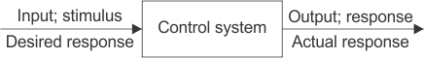

Figure 1.0 Open Loop Control System

Control system engineering focuses on analysis and design of systems to improve the speed of response, accuracy and stability of system. The two methods of control system include classical methods and modern methods. The mathematical model of system is set up as first step followed by analysis, designing and testing. Necessary conditions for the stability are checked and finally optimization follows.

In classical method, mathematical modeling is usually done in time domain, frequency domain or complex s domain. Step response of a system is mathematically modeled in time domain differential analysis to find its settling time, % overshoot etc. Laplace transforms are most commonly used in frequency domain to find the open loop gain, phase margin, band width etc of system. Concept of transfer function, sampling of data, poles and zeros, system delays all comes under the classical control engineering stream.

Modern control engineering deals with Multiple Input Multiple Output (MIMO) systems, State space approach, Eigen values and vectors etc. Instead of transforming complex ordinary differential equations, modern approach converts higher order equations to first order differential equations and solved by vector method. Automatic control systems are most commonly used as it does not involve manual control. The controlled variable is measured and compared with a specified value to obtain the desired result. As a result of automated systems for control purposes, the cost of energy or power as well as the cost of process will be reduced increasing its quality and productivity.

Types of Control Engineering

Control engineering has its own categorization depending on the different methodologies used, which are as follows.

- Classical Control Engineering :

The systems are usually represented by using ordinary differential equations. In classical control engineering, these equations are transformed and analyzed in transformed domain. Laplace transform, Fourier transform and z transform are examples. This method is commonly used in Single Input Single Output systems.

- Modern Control Engineering :

In modern control engineering higher order differential equations are converted to first order differential equations. These equations are solved very similar to vector method. By doing so, many complications dealt in solving higher order differential equations are solved. These are applied in Multiple Input Multiple Output systems where analysis in frequency domain is not possible. Nonlinearities with multiple variables are solved by modern methodology. State space vectors, Eigen values and Eigen Vectors longs to this category. State Variables describe the input, output and system variables.

- Robust Control Engineering :

In robust control methodology, the changes in performance of system with change in parameters are measured for optimization. This aids in widening the stability and performance, also in finding alternate solutions. Hence in robust control the environment, internal in accuracies, noises and disturbances are considered to reduce the fault in system.

- Optimal Control Engineering :

In optimal control engineering, the problem is formulated as mathematical model of process, physical constraints and performance constraints, to minimize the cost function. Thus optimal control engineering is the most feasible solution for designing a system with minimum cost.

- Adaptive Control Engineering :

In adaptive control engineering, the controllers employed are adaptive controllers in which parameters are made adaptive by some mechanism. The block diagram given below shows an adaptive control system.

In this kind of controllers an additional loop for parameter adjustment is present in addition to the normal feedback of process

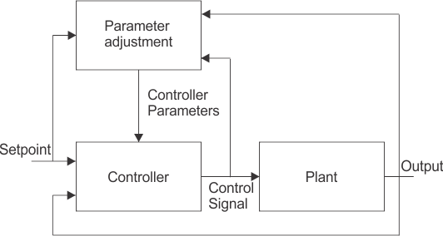
Figure 1.1 Adaptive Control System

- Nonlinear Control Engineering :

Non linear control engineering focuses on the non linearity’s which cannot be represented by using linear ordinary differential equations. This system will exhibit multiple isolated equilibrium points, limit cycles, bifurcations with finite escape time. The main limitation is that it requires laborious mathematical analysis. In this analysis the system is divided into linear part and non linear part.

- Game Theory :

In game theory, each system will have to reduce its cost function against the disturbances / noises. Hence it is a study of conflict and co operation. The disturbances will try to maximize the cost function. This theory is related to robust and optimal control engineering.

Types of Control Systems | Linear and Non Linear Control System

Linear Control Systems

In order to understand the linear control system, we should know the principle of superposition. The principle of superposition theorem includes two the important properties and they are explained below: Homogeneity : A system is said to be homogeneous, if we multiply input with some constant ‘A’ then output will also be multiplied by the same value of constant (i.e. A). Additivity: Suppose we have a system ‘S’ and we are giving the input to this system as ‘a₁’ for the first time and we are getting output as ‘b₁’ corresponding to input ‘a₁’. On second time we are giving input ‘a₂’ and correspond to this we are getting output as ‘b₂’. Now suppose this time we giving input as summation of the previous inputs ( i.e. a₁ + a₂ ) and corresponding to this input suppose we are getting output as (b₁ + b₂) then we can say that system ‘S’ is following the property of additivity. Now we are able to define the linear control systems as those types of control systems which follow the principle of homogeneity and additivity.
Examples of Linear Control System
Consider a purely resistive network with a constant DC source. This circuit follows the principle of homogeneity and additivity. All the undesired effects are neglected and assuming ideal behavior of each element in the network, we say that we will get linear voltage and current characteristic. This is the example of linear control system.

Non-linear Systems

We can simply define non linear control system as all those system which do not follow the principle of homogeneity. In practical life all the systems are non-linear system.

Examples of Non-linear System

A well known example of non-linear system is magnetization curve or no load curve of a DC machine. We will discuss briefly no load curve of DC machines here: No load curve gives us the relationship between the air gap flux and the field winding mmf. It is very clear from the curve given below that in the beginning there is a linear relationship between winding mmf and the air gap flux but after this, saturation has come which shows the non linear behavior of the curve or characteristics of the non linear control system.

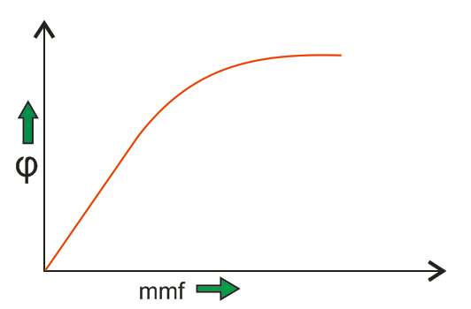

Figure 1.3 Non Linear System Example

Analog or Continuous System

In these types of control system we have continuous signal as the input to the system. These signals are the continuous function of time. We may have various sources of continuous input signal like sinusoidal type signal input source, square type of signal input source, signal may be in the form of continuous triangle etc.

Digital or Discrete System

In these types of control system we have discrete signal (or signal may be in the form of pulse) as the input to the system. These signals have the discrete interval of time. We can convert various sources of continuous input signal like sinusoidal type signal input source, square type of signal input source etc into discrete form using the switch.
Now there are various advantages of discrete or digital system over the analog system and these advantages are written below:
- Digital systems can handle non linear control systems more effectively than the analog type of systems.
- Power requirement in case of discrete or digital system is less as compared to analog systems.
- Digital system has higher rate of accuracy and can perform various complex computations easily as compared to analog systems.
- Reliability of digital system is more as compared to analog system. They also have small and compact size.
- Digital system works on the logical operations which increases their accuracy many times.
- Losses in case of discrete systems are less as compared to analog systems in general.
Single Input Single Output Systems
These are also known as SISO type of system. In this the system has single input for single output. Various example of this kind of system may include temperature control, position control system etc.
Multiple Input Multiple Output Systems
These are also known as MIMO type of system. In this the system has multiple outputs for multiple inputs. Various example of this kind of system may include PLC type system etc.

Lumped Parameter System

In these types of control systems the various active (resistor) and passive parameters (like inductor and capacitor) are assumed to be concentrated at a point and that’s why these are called lumped parameter type of system. Analysis of such type of system is very easy which includes differential equations.

Distributed Parameter System
In these types of control systems the various active (resistor) and passive parameters (like inductor and capacitor) are assumed to be distributed uniformly along the length and that’s why these are called distributed parameter type of system. Analysis of such type of system is slightly difficult which includes partial differential equations.

