CHAPTER 1

What are we going to Control?

A control system is an interconnection of components forming a system configuration that will provide a desired system response. The basis of analysis of a system is the foundation provided by linear system theory which assumes a cause –effect relationship for the components of a system. Therefore a component or process to be controlled can be represented by a block.

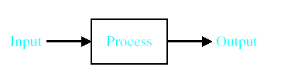
Figure 1.4 Simple Open Loop Control System

Process/Plant : the physical system some aspect of which is to be controlled.
e.g - electric motor
- oven
- aircraft

Input : The variable which may be adjusted to bring about the required control action (also know on the actuating Signal).
e.g - Voltage applied to motor.
- power Input to oven.
- aircraft control surface position .

Output : The variable to be controlled.
e.g - Motor Speed.
- Oven temp.
- Aircraft altitude.

Motor
W
V

Figure 1.5 Example of a Simple Control System

In this context, inputs and outputs present signal flow through the control system.

The Aim of the Control System:

To control the output of the process in some prescribed manner through appropriate adjustment of the input.

Manual Control System

A manual control system for regulating the level of fluid in a tank by adjusting the output valve . the operator views the level of fluid through a port in the side of the tank

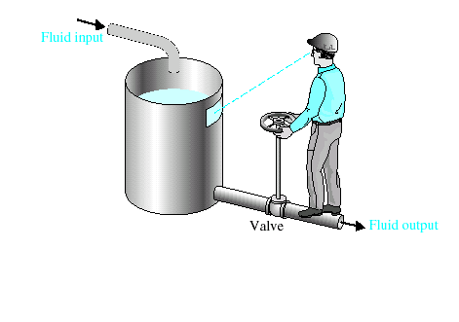

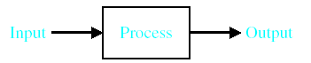

Figure 1.6 Example of a Simple Control System

Automatic control system

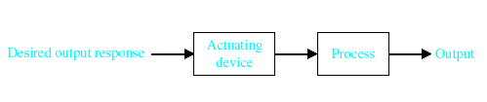
Figure 1.7 Example of Automatic Control System

Control Strategies:
The general problem:

Actuating
signal

u(t)

output

c(t)

r(t)

Controller

Process

Figure 1.8 Control Problem
The controller generates an appropriate actuating signal u(t) to produce the required process output c(t). The controller receives external information, e.g – the desired output r(t). it also contains Built in information, e.g how the process is likely to respond to a given actuating signal.

Open Loop Control System

A control system in which the control action is totally independent of output of the system then it is called open loop control system. Manual control system is also an open loop control system. Fig 1.8 shows the block diagram of open loop control system in which process output is totally independent of controller action.

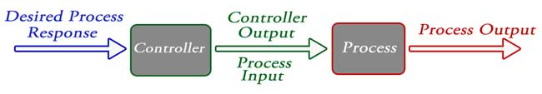

r(t) u(t) c(t)

Desired output Actuating signal Actual output

Controller
Process

Figure 1.9 Open loop control system

The controller behaves as “inverse model” of the process. The only input to the controller is the desired output r(t). or a given r(t) the controller always generates the same actuating signal u(t)

Practical Examples of Open Loop Control System

- Electric Hand Drier – Hot air (output) comes out as long as you keep your hand under the machine, irrespective of how much your hand is dried.
- Automatic Washing Machine – This machine runs according to the pre-set time irrespective of washing is completed or not.
- Bread Toaster - This machine runs as per adjusted time irrespective of toasting is completed or not.
- Automatic Tea/Coffee Maker – These machines also function for pre adjusted time only.
- Timer Based Clothes Drier – This machine dries wet clothes for pre – adjusted time, it does not matter how much the clothes are dried.
- Light Switch – lamps glow whenever light switch is on irrespective of light is required or not.
- Volume on Stereo System – Volume is adjusted manually irrespective of output volume level.

Advantages of Open Loop Control System
- Simple in construction and design.
- Economical.
- Easy to maintain.
- Generally stable.
- Convenient to use as output is difficult to measure.

Disadvantages of Open Loop Control System
- They are inaccurate.
- They are unreliable.
- Any change in output cannot be corrected automatically.

Open-loop control cannot compensate for disturbance Inputs to the process or for process parameter variations.
An open loop control system utilizes an actuating device to control the process directly without using feedback.

Closed Loop (Feedback) Control System

Control system in which the output has an effect on the input quantity in such a manner that the input quantity will adjust itself based on the output generated is called closed loop control system. Open loop control system can be converted in to closed loop control system by providing a feedback. This feedback automatically makes the suitable changes in the output due to external disturbance. In this way closed loop control system is called automatic control system. Figure below shows the block diagram of closed loop control system in which feedback is taken from output and fed in to input.

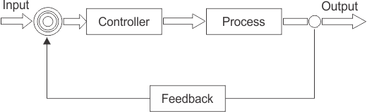

Figure 1.10 Closed Loop Control System

The process output is measured and compared with the desired output. Any difference between the desired output and the actual ouput is compensated for by the controller which generates a correcting actuating signal u(t).The measure of the output is called feedback signal.

Practical Examples of Closed Loop Control System

- Automatic Electric Iron – Heating elements are controlled by output temperature of the iron.
- Servo Voltage Stabilizer – Voltage controller operates depending upon output voltage of the system.
- Water Level Controller– Input water is controlled by water level of the reservoir.
- Missile Launched & Auto Tracked by Radar – The direction of missile is controlled by comparing the target and position of the missile.
- An Air Conditioner – An air conditioner functions depending upon the temperature of the room.
- Cooling System in Car – It operates depending upon the temperature which it controls.

Advantages of Closed Loop Control System
- Closed loop control systems are more accurate even in the presence of non-linearity.
- Highly accurate as any error arising is corrected due to presence of feedback signal.
- Bandwidth range is large.
- Facilitates automation.
- The sensitivity of system may be made small to make system more stable.
- This system is less affected by noise.

Disadvantages of Closed Loop Control System

- They are costlier.
- They are complicated to design.
- Required more maintenance.
- Feedback leads to oscillatory response.
- Overall gain is reduced due to presence of feedback.
Stability is the major problem and more care is needed to design a stable closed loop system

Comparison of Closed Loop and Open Loop Control System

Sr. No. | Open loop control system | Closed loop control system
1 | The feedback element is absent. | The feedback element is always present.
2 | An error detector is not present. | An error detector is always present.
3 | It is stable one. | It may become unstable.
4 | Easy to construct. | Complicated construction.
5 | It is an economical. | It is costly.
6 | Having small bandwidth. | Having large bandwidth.
7 | It is inaccurate. | It is accurate.
8 | Less maintenance. | More maintenance.
9 | It is unreliable. | It is reliable.
10 | Examples: Hand drier, tea maker | Examples: Servo voltage stabilizer, perspiration

Table 1.0 Comparison of open and closed loop system

Feedback Loop of Control System

A feedback is a common and powerful tool when designing a control system. Feedback loop is the tool which take the system output into consideration and enables the system to adjust its performance to meet a desired result of system. In any control system, output is affected due to change in environmental condition or any kind of disturbance. So one signal is taken from output and is fed back to the input. This signal is compared with reference input and then error signal is generated. This error signal is applied to controller and output is corrected. Such a system is called feedback system. Figure below shows the block diagram of feedback system.

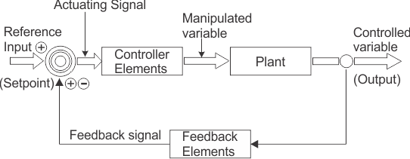

Figure 1.11 Closed Loop Control System

When feedback signal is positive then system called positive feedback system. For positive feedback system, the error signal is the addition of reference input signal and feedback signal. When feedback signal is negative then system is called negative feedback system. For negative feedback system, the error signal is given by difference of reference input signal and feedback signal.

Effect of Feedback
Refer figure beside, which represents feedback system where R = Input signal E = Error signal G = forward path gain H = Feedback gain C = Output signal B = Feedback signal

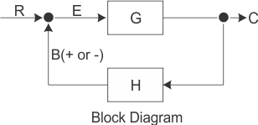

Figure 1.12 Effect of Feedback

- Error between system input and system output is reduced.
- System gain is reduced by a factor 1/(1±GH).
- Improvement in sensitivity.
- Stability may be affected.
- Improve the speed of response.

Feed Forward Control:

Disturbances

Measured disturbances

r(t) u(t) c(t)
Output

Controller
Process
Input

Figure 1.13 Feed Forward

In feed forward control, the disturbances are Measured directly and their effect on the process compensated for in the controller.

An effective strategy if the disturbances have a known effect and can be easily measured, However, cannot compensate for parameter variations.

Multivariable Control

In general a process will have a number of outputs which are to be controlled and a number of inputs which may be varied , any one output will probably be influenced by more than one input (a coupled system).

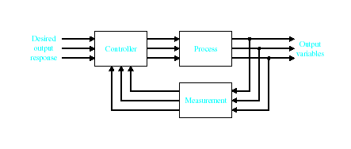
Figure 1.14 Multivariable Control

Such a system is a multivariable system. Multivariable control theory is complex. We will consider only single variable systems.

Disturbances:
control. A process is normally subjected to other types of Inputs which affect its performance.
e.g variation in motor Mechancial load
Changes in oven ambient temperature
wind gusts in aircapt flight path.
Such imputs are called disturbances. We have no control over disturbances but they can often be measured and their effects must be taken into consideration to achieve accurate results

Disturbances load torque
td

Input Output V ω

Voltage Speed
Process
Motor

Figure 1.15 Disturbances

Parameter Variations:

Similar undesirable effects are caused by changes in characteristics of the process.
e.g - Motor winding resistance varying.
- changes in characteristics of oven.
- heating element.
- variation in friction in aircraft.
- control surface actuators.
The Parameter Variations affect the perfermance of the process. Unlike disturbances, parameter variations are internal to the process and usually cannot be readily Measured.

INPUT OUTPUT
Process
Parameter
Variations

Figure 1.16 Parameter Variations

History of Automatic control systems

The first Historical feedback system claimed by Russia is the water level float regulator shown below.

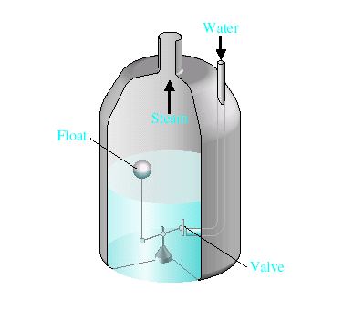
Figure 1.17 Water Level float regulator

The float detects the water level and controls the valve that covers the water inlet in the boiler

Control System Desisgn

Figure 1.18 Control Process

Step1
Example- Control of motor Velocity or Position accurately.

Step2
Example- Variables to be controlled velocity of motor.

Step3
Example- How accurate do we want it to be, if 5000r.p.m is optimal? Will 4990 r.p.m (revolution per minute) do this will lead to the identification of the sensor.

Step4
Configure what we need in a system. It will normally consist of a sensor, the process under control, an actuator and a controller as shown below.

Figure 1.19 Block diagram

Identify a candidate for the actuator. This will ofcourse depend on the process. But the actuation chosen must be capable of effectively adjustng the performance of the process. For example if we wish to control the speed of a rotating flywheel, we will select a motor as the actuator and a tachogenerator as the sensor.

Step5
Obtain a model for each of these elements.

Step 6-
Select the controller. This is often consists of a summing amplifier that compares the desired response and actual response and then forward this error signal to an amplifier.

Step7
The final step in the design performance. If we can achieve the desired performance by adusting the parameters w will finalise the design. If not we need to establish an improved System Configuration and perhaps select a different sensor and/or different actuator.

Design Examples of Modern control Systems:

Example 1.1

The open-loop system without feedback is shown below. This system uses a battery source to provide a voltage that is proportional to the desired speed. This voltage is amplified and applied to the motor.

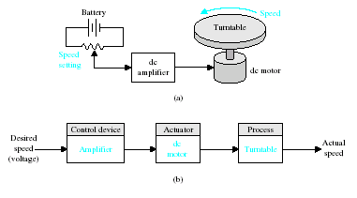

Figure 1.20 a) open-loop control of speed of a turntable
b) Block diagram model

To obtain a feedback system with general form, we need to select a sensor. One useful sensor is a tachometer that provides an output voltage proportional to the speed of its shaft. The error voltage is generated by the difference between the input voltage and the tachometer voltage.

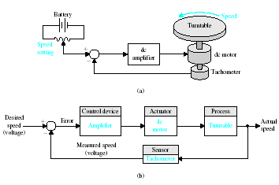

Figure 1.21 a) Closed loop control of the speed of a turntable
b) Block diagram model

Example 1.2

Step1 is to design a system to regulate the blood sugar concentration of a diabetic. The blood glucose and insulin concentrations for a healthy person are shown in figure 1.22. The system must provide the insulin from a reservoir implanted within the diabetic person.

Step 2 the variable we wish to control is the blood glucose concentration

Step 3 the specification for the control system is to provide a blood glucose level for the diabetic that closely approximates (tracks) the glucose level of a healthy person.

Step 4 we propose a preliminary system configuration. An open-loop system would use a preprogrammed signal generator and miniature motor pump to regulate the insulin delivery rate as shown in figure 1.23a. The feed back control system would use a sensor to measure the actual glucose level and compare that level with the desired level, thus tuning the motor pump on when it is required as shown in figure 1.23b

Note- a drug delivery system implemented in the body uses an open-loop system, since miniaturized glucose sensors are not yet available. The best solutions rely on individually programmable pocket sized insulin pumps that can deliver insulin according to a preset time history.

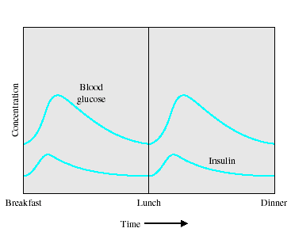

Figure 1.22 The blood glucose and insulin levels for a healthy person

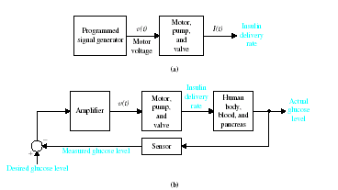

Figure 1.23 a) Open-Loop (without feedback)control and
b) Closed loop control of blood glucose

Example 1.3

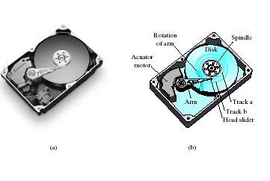

Figure 1.24 diagram of disk drive

Step 1

the goal of the disk drive reader device is to position the reader head in order to read the data stored on the track on the disk

Step 2

the variable to accurately control is the position of the reader head (mounted on a slider device).

Step 3

the disk rotates at a speed of between 1800 and 7200 rpm, and the head “flies” above the disk at a distance of less than 100nm. The initial specification for the position accuracy is 1 micro meter

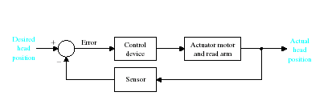

Figure 1.25 closed loop control system for disk drive

