CHAPTER 5 (b)

Time Domain Specification

Standard performance measures are usually defined in terms of step response of a system as shown in the figure on the next page. The swiftness of the response is measured by the rise time $T_{r}$ and the peak time $T_{p}$. For underdamped systems with an overshoot, the $0−\text{100}$% rise time is a useful index. If the system is overdamped then the peak time is not defined and the 10-90% rise time is normally used

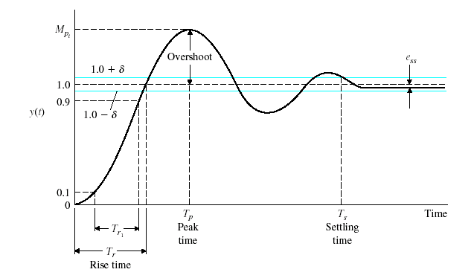
$$T_{d}$$

Figure 5.13

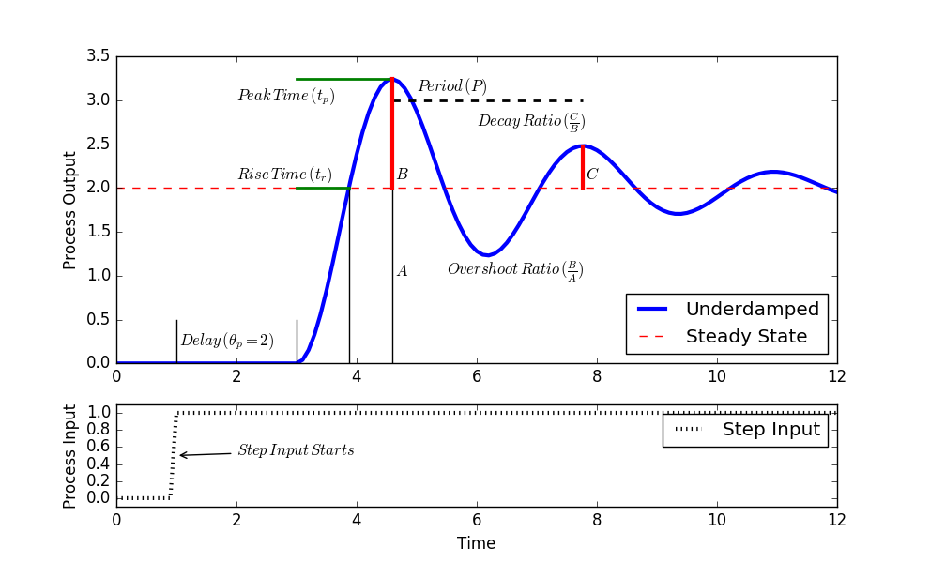

Figure 5.13 b

Definitions

$T_{r1}$ Rise time ,the time required for the step response to rise from 10% to 90% of its final value.

$$\begin{aligned}0 \\ \end{aligned}$$

$T$ Period of oscillation

$$T=2T_{p}=\frac{2π}{ω_{n}\sqrt{1−ξ^{2}}}$$

$T_{s}$ Settling time, the time required for the step response to decrease and stay within a specification percentage of its final value (typically within ±2%,±5%).

±2%
$$T_{s}=\frac{4}{{\text{ξω}}_{n}}\text{ seconds}$$

±5%
$$T_{s}=\frac{3}{{\text{ξω}}_{n}}\text{ seconds}$$

$$\begin{aligned}T_{p}=\frac{π}{ω_{n}\sqrt{1−ξ^{2}}}=\frac{π}{ω_{d}}\text{ where }ω_{n}=\text{ rad/sec} \\ ω_{d}=ω_{n}\sqrt{1−ξ^{2}}=\text{ damped natural frequency}\end{aligned}$$

$M_{p}$ Maximum overshoot, the amount that the wave form exceeds the final value (steady state)

$$\begin{aligned}M_{p}=1+e^{−\text{ξπ}\sqrt{1−ξ^{2}}} \\ {\%M}_{p}=\text{100}e^{−\text{ξπ}\sqrt{1−ξ^{2}}}\end{aligned}$$

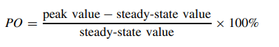

$T_{d}$ Delay time, the time required for the step response to reach 50% of its final value.

$$\begin{aligned}0 \\ \end{aligned}$$

Decay ratio ,$M_{p}M_{2}$ exponential decay between the maximum overshoot and the second overshoot

$$\frac{M_{P}}{M_{2}}=e^{−2\text{πξ}\sqrt{1−ξ^{2}}}$$

Example
Consider the system shown in figure --- below where ξ=0.6 and ω_{n} =5 rad/sec. Let us obtain the rise time t_{R} , peak time t_{p}, Maximum overshoot M_{p} and settling time t_{s} when the system is subjected to a unit step input

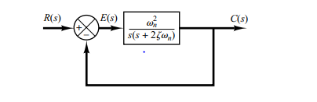
Rise time
$$\begin{aligned}0 \\ \end{aligned}$$

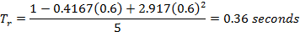

Peak time

$$T_{p}=\frac{π}{ω_{n}\sqrt{1−ξ^{2}}}=\frac{π}{5\sqrt{1−{(0\text{.}6)}^{2}}}=\frac{π}{5\sqrt{1−0\text{.}\text{36}}}=0\text{.}\text{785}$$

Maximum overshoot

$$\begin{aligned}{\%M}_{p}=\text{100}e^{−\text{ξπ}\sqrt{1−ξ^{2}}}=\text{100}e^{−(0\text{.}6)π/\sqrt{1−{(0\text{.}6)}^{2}}}=0\text{.}\text{095}=9\text{.}5\text{\%} \\ \end{aligned}$$
Settling time
$$T_{s}=\frac{4}{{\text{ξω}}_{n}}=\frac{4}{0\text{.}6×5}=1\text{.}\text{33 seconds}$$

Period of Oscillation

$$T=2T_{p}=\frac{2π}{ω_{n}\sqrt{1−ξ^{2}}}=2×0\text{.}\text{785}=1\text{.}\text{57}\text{sec}\text{onds}$$

As can be seen from the figure below the location of the poles effect the transient and the steady state response. It can also be seen why the roots must have –ve real part.

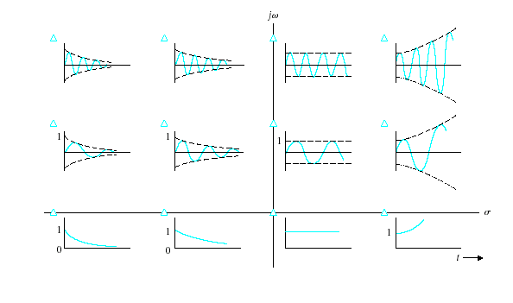

Figure------

