**CHAPTER 5 (a)**

**The Performance of Feedback Control Systems**

One of the first steps in the design process is to specify the measures of performance. N this chapter we introduce the common time-domain specifications such as percent overshoot, settling time, peak time, rise time and steady-state tracking error

The **design specifications** for control systems normally include several time-response indices for a specified input command as well as a desired steady state accuracy. Often in the course of any design the specifications are revised to effect a compromise. Therefore specifications are seldom a rigid requirement.

Since time is used as an independent variable in most control systems. It is usually of interest to evaluate the state and output responses with respect to time or simply the **TIME RESPONSE.**

The time response of a control system is usually divided into two parts. The **TRANSIENT RESPONSE** and the **STEADY STATE RESPONSE.**



**In control systems transient response is defined as the part of the time response that goes to zero as time becomes very large **

**The steady state response is simply the part of the total response that remains after the transient has died out.** Thus the steady state can still vary in a fixed pattern such as a sine wave or a ramp function that increases with time.

All real control systems exhibit transient phenomena to some extent before the steady state is reached. Since Inertia, Mass and Inductance are unavoidable in real systems. Therefore the transient phenomena must be closely controlled.

The steady state response of a control system is also very important. Since it indicates where the output of the system ends up when time becomes very large. For a position control system the steady state response when compared with the desired reference position gives an indication of the final accuracy of the system. In general if the steady state response of the output does not agree with the desired reference exactly, the system is said to have a **steady state error**

The study of a control system in the time domain essentially involves the evaluation of the transient and steady state response of the system. The design problem specification are usually given in terms of the transient and the steady state performances and controllers insure that the specifications are met.

**Initial conditions and their effect on second order system:**

M

x

B

K

F

Figure 5.4

The system differential equation is



Consider the same arrangement but without an external force and with initial conditions

K

B

where 

M

x

Figure 5.5

The system differential equation is



The above equation is a second order system. However a standard second order equation can be written as follows



Thus the damping ratio and the undamped natural frequency may be calculated from the system parameters

Now Consider our T.F



**Performance Of Second Order System**

**Test Signals for the Time Response of Control Systems**

Unlike electrical networks and communication systems, the inputs to many practical systems are not exactly known a head of time. In many cases, the actual inputs of a control system may vary in random fashion with respect to time i.e. (Radar tracking system and aircraft missile).

For the purposes of analysis and design it is necessary to assume some basic types of test input signals so that the performance of a system can be evaluated. By selecting these basic test signals properly, not only is the mathematical treatment of the problem systemized but the response due to these input signals allows the prediction of the system performance to other more complex inputs.

To facilitate the time domain analysis, the following deterministic test signals are used

**STEP-FUNCTION INPUT**

The step function input represents an instantaneous change in the reference input. For example if the input is an angular position of a mechanical shaft, a step input represents the sudden rotation of the shaft. The mathematical representation of a step function of magnitude A is



Where A is a Real constant



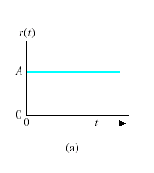

Figure 5.1

The step function is very useful as a test signal. Since its initial instantaneous jump in amplitude reveals a great deal about a system’s quickness in responding to input with abrupt changes. Also since the step function contains in principle a wide band of frequencies in its spectrum as a result of the jump discontinuity, it is equivalent to the application of numerous sinusoidal signals with a wide range of frequencies

**RAMP-FUNCTION INPUT**



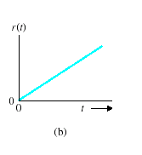

Figure 5.2

The ramp function is a signal that changes constantly with time. If the input variable represents the angular displacement of a shaft, the ramp input denotes the constant speed rotation of the shaft. The ramp input function has the ability to test how he system would respond to a signal that changes linearly with time.

**PARABOLIC-FUNCTION INPUT**

The parabolic function represents a signal that is one order faster than the ramp function. Mathematically it is represented as



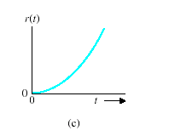

Figure 5.3

The factor half is added for mathematical convenience since the Laplace of r(t) is simply .

These signals have the common feature that they are simple to describe mathematically. The signals become progressively faster with respect to time. In theory we can define signals with still higher rates such as  which is called the jerk function and so on. However in reality we seldom find it necessary or feasible to use test signals faster than parabolic function.

**Time Response of control systems**

SHAPING THE DYNAMIC RESPONSE

In addition to closed-loop asymptotic stability which requires that the closed-loop system dynamics matrix have strictly negative real-part eigenvalues (poles), we are often interested in other characteristics of the closed-loop transient response, such as **rise time**, **peak time**, **percent overshoot**, and **settling time** of the step response. Before we investigate the extent to which state feedback can influence the closed loop eigenvalues (poles), we first review topics associated with transient response performance of feedback control systems. In our state-space context, we seek to translate desired transient response characteristics into specifications on system eigenvalues, which are closely related to transfer function poles. **Specifying desired closed-loop system behavior via eigenvalue selection is called shaping the dynamic response**. Control system engineers often use dominant first- and second-order subsystems as approximations in the design process, along with criteria that justify such approximations for higher-order systems. Our discussion follows this approach.

**Laplace of first order system**

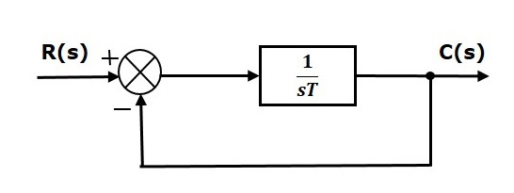

Figure 1 first order closed loop system

The transfer function of the closed loop control system has unity negative feedback,

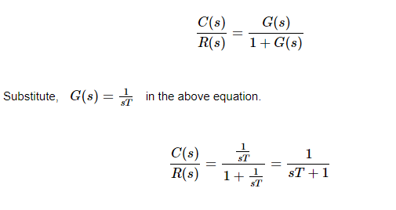

The power of s is one in the denominator term. Hence, the above transfer function is of the first order and the system is said to be the **first order system**.

We can re-write the above equation as

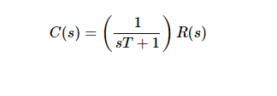

Where,

* **C(s)** is the Laplace transform of the output signal c(t),
* **R(s)** is the Laplace transform of the input signal r(t), and
* **T** is the time constant.

Apply Laplace transform on both the sides with a step input .



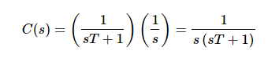

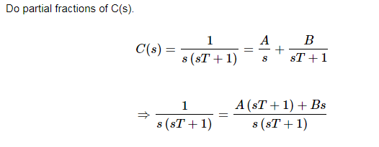

On both the sides, the denominator term is the same. So, they will get cancelled by each other when we cross multiply. Hence, equate the numerator terms.



By equating the constant terms on both the sides, you will get A = 1.Substitute, A = 1 and equate the coefficient of the **s** terms on both the sides.



Substitute, A = 1 and B = −T in partial fraction expansion of C(s).

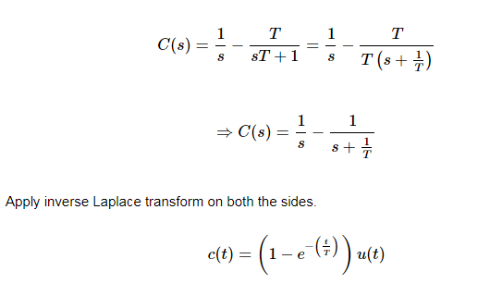

The **unit step response**, c(t) has both the transient and the steady state terms.

The transient term in the unit step response is -



The steady state term in the unit step response is –



Therefore the time response is shown in figure below

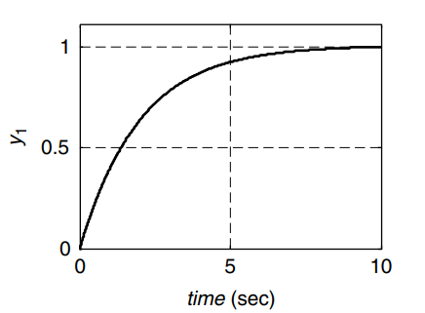

**Figure 2 unit step response for a First order System**

the value of the **unit step response, c(t)** is zero at t = 0 and for all negative values of t. It is gradually increasing from zero value and finally reaches to one in steady state. So, the steady state value depends on the magnitude of the input.

If we substitute into the equation

Figure 3 shows the curve for this first order system

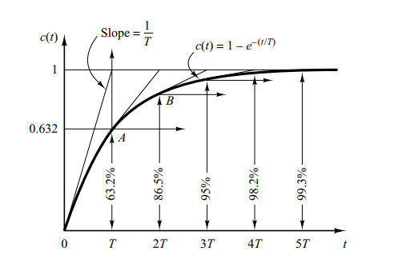

**Figure 3 Detailed unit step response for a First order System**

**Eigenvalue Selection for First-Order Systems**

Figure 2.0 shows unit step responses of typical of first- systems. For a first-order system, we can achieve desired transient behavior via specifying a single eigenvalue as shown in figure 3 above.

All stable first-order systems driven by unit step inputs behave this way, with transient response governed by a single decaying exponential involving the time constant T After three time constants, the first-order unit step response is within 95 percent of its steady state value. A smaller time constant responds more quickly, whereas a larger time constant responds more slowly. On specifying a desired time constant, the associated characteristic polynomial and eigenvalue are

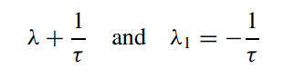

Or in terms of Laplace transforms