|  |  |
| --- | --- |
| Experiment No : 7 | Pulse width modulation (PWM) |

**Objectives:**

To learn about Pulse width modulation (PWM) and make a control of speed and direction of DC motor by using h-bridge (L298)

**Pulse width modulation (PWM),** or pulse-duration modulation (PDM), is a method of reducing the average power delivered by an electrical signal, by effectively chopping it up into discrete parts. The average value of [voltage](https://en.wikipedia.org/wiki/Volt) (and [current](https://en.wikipedia.org/wiki/Electric_current)) fed to the [load](https://en.wikipedia.org/wiki/Electrical_load) is controlled by turning the switch between supply and load on and off at a fast rate. The longer the switch is on compared to the off periods, the higher the total power supplied to the load

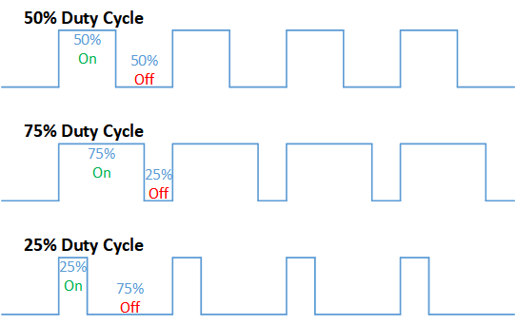

**L298 (h-bridge)**

The L298 is an integrated monolithic circuit in a 15- lead Multiwatt and PowerSO20 packages. It is a high voltage, high current dual full-bridge driver designed to accept standard TTL logic levels and drive inductive loads such as relays, solenoids, DC and stepping motors. Two enable inputs are provided to enable or disable the device independently of the input signals. The emitters of the lower transistors of each bridge are connected together and the corresponding external terminal can be used for the connection of an external sensing resistor. An additional supply input is provided so that the logic works at a lower voltage.

**L298 characteristic:**

. Operating supply voltage up to 6v

. Total DC current up to 4 A

. Low saturation voltage

. Over temperature protection

. Logical 0 input voltage up to 1.5 v (high noise immunity)

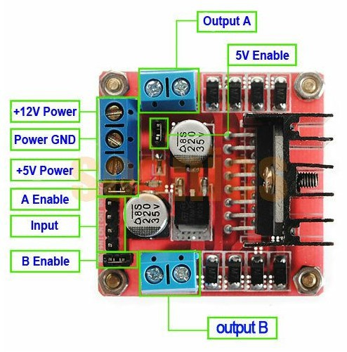

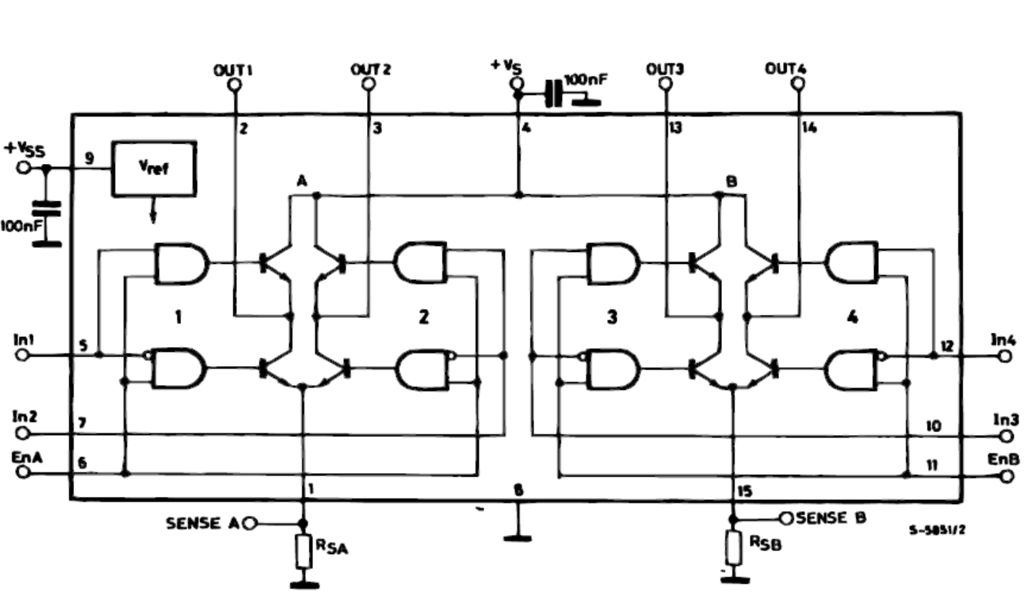

**Example 1:** control the position and direction of DC motor

The goal from this example to is to control the position and direction of DC motor by using h-bridge

**Components:**

1. PIC16f877a form (Component mode)
2. Lm016L(Component mode)
3. Pot-hg (Component mode)
4. Button (Component mode)
5. L298 (Component mode)
6. Motor (Component mode)
7. Dc (generator mode)
8. Power (terminal mode)
9. Ground (terminal mode)
10. Oscilloscope (instruments)

**Proteus:**

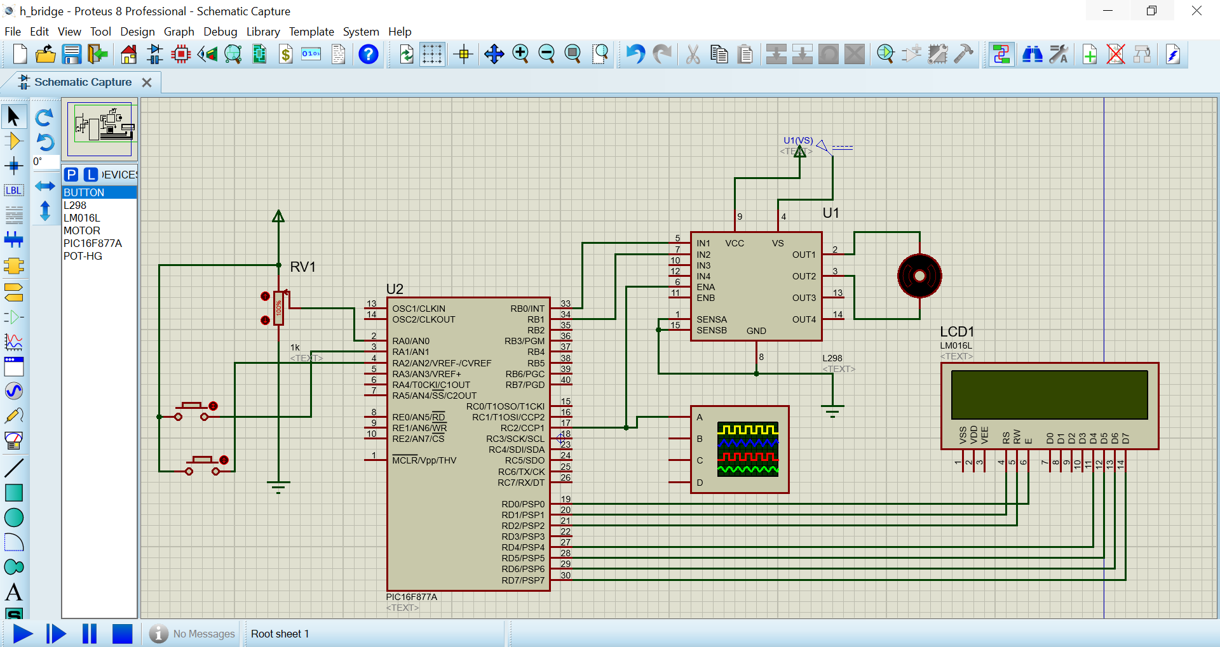

**PIC C:**



