Chapter 15

Accounting for Bonds Issue

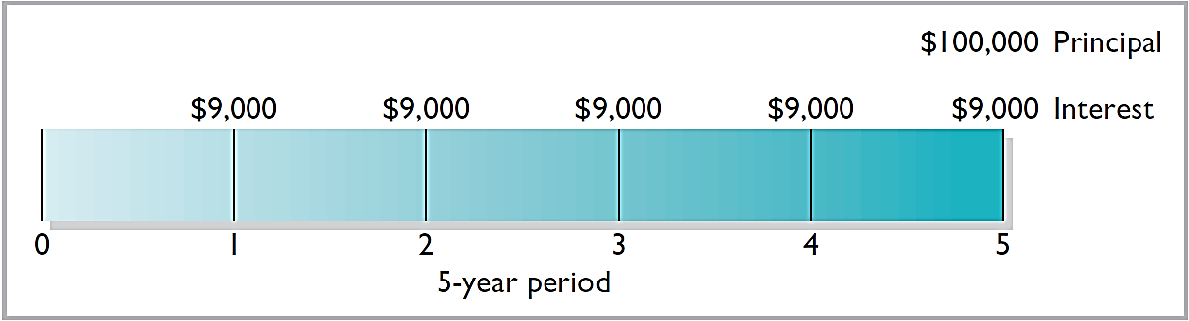

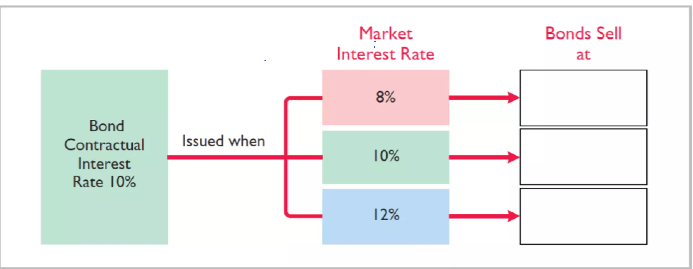

1- Issuing Bonds of face value:

2- Issuing Bonds at discount:

3- Issuing Bonds at premium:

**Example**:

On 1/1/2018, Company X issued 1000 bonds with a face value of $100 per bond, with an annual interest rate of 8%, and a bond maturity of 5 years.

**Required**: The accounting entry at the issuance of bonds on 1/1/2018, the entry for the interest payment on 12/31/2018, the entry for the repayment in the fifth year, and how the bond payable appears on the balance sheet on 12/31/2018.

**Assume the sale was:**

1- At the face value of the bond ($100)

2- At $105 per bond

3- At $95 per bond

First case: face value of the bond ($100)

Issuance value: 100 * 1000 = 100,000

Face value = 100 * 1000 = 100,000

1/1/2018

Cash 100,000

Bonds payable 100,000

31/12/2018

Interest expense 8,000

Interest payable 8,000

When paid:

Interest payable 8,000

Cash 8,000

Second Case: At $105 per bond

Issuance value: 100 * 1000 = 100,000

market value: 105 * 1000 = 105,000

Cash 105,000

Premium 5,000

Bonds payable 100,000

Third Case: At $ 95 per bonds

Issuance value: 100 * 1000 = 100,000

Market value : 95 * 1000 = 95,000

Cash 95,000

Discount 5,000

Bonds payable 100,000