**Example 5:** time and date

The goal from this example to show on the lcd the date and time with possibility to change the hour in the time

**Components:**

1. PIC16f877a form (Component mode)
2. LM016L (Component mode)
3. Push button

**Proteus:**

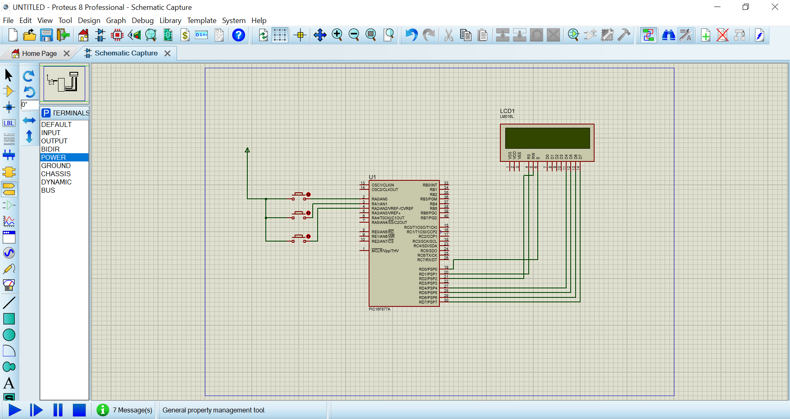

**PIC C** : nested for is used here every 1 s the for loop for seconds increased by 1 when the seconds is reach 30 the minute is increase by 1 when the minute reach 30 minute the hour is increased by 1 and so on the delay is used here is 1000 ms refer to 1 s , while statement is used here to stop the watch when press the push button connected to pin a0 then when press the push button connected to pin a1the hour increased by 1 then when press the push button connected to pin a2the hour decreased by 1

