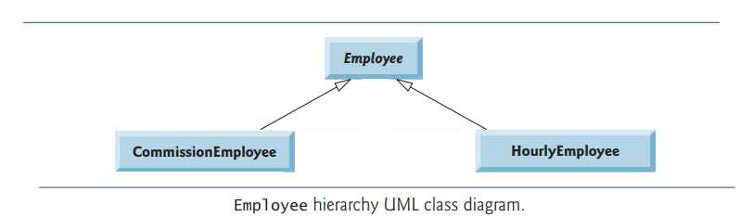

|  |
| --- |
| **Employee** |
| String: fName  String: lName  String: ssn |
| toString(): prints information of employee  earning(): compute the salary of employee |

|  |
| --- |
| **CommissionEmployee** |
| Double: grossSales // must be greater than zero  Double: commissionRate // must be between 0.0 and 1.0 |
| earning () = commissionRate * grossSales |

|  |
| --- |
| HourlyEmployee |
| Double: wage // must be greater than 0.0  Double: hours // must be between 0.0 and 168.0 |
| Earning () // If no. of hours <= 40 then there is no overtime and earning = wage * hours.  Else, earning = 40 * wage + (hours – 40) * wage * 1.5 |