**Eigenvalue Selection for Second-Order Systems**

For a second-order system, we can achieve desired transient behavior via specifying a pair of eigenvalues. To illustrate, we consider the linear translational mechanical system of a previous example shown below with applied force f (t) as the input and mass displacement y(t) as the output. We identify this with a standard second-order system by redefining the input via u(t) = f (t)/k. The new input u(t) can be interpreted as a commanded displacement.

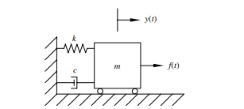

**Figure 4 Mechanical system**

The state equation for figure 4 is

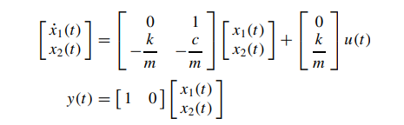

with associated transfer function

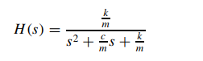

We compare this with the standard second-order transfer function, namely,

The transient response of this second order system for various values of the damping ratio  is shown below

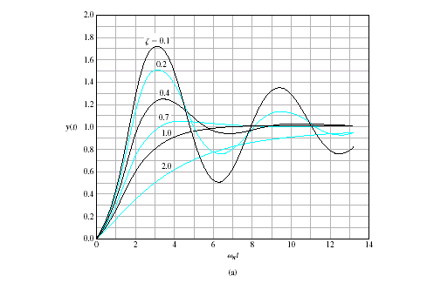

Figure---------------

It can be seen that as  decreases the closed loop roots approach the imaginary axis and the response becomes increasingly oscillatory.

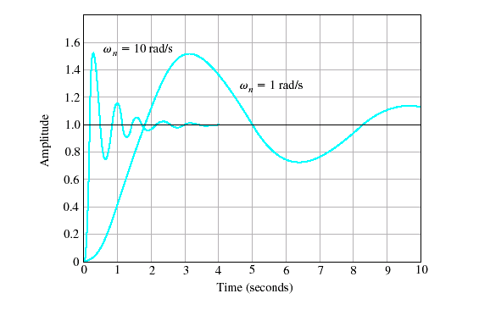

Figure----------------

in which ξ is the unit less damping ratio, and ωn is the un damped natural frequency in radians per second. This leads to the relationships

Therefore

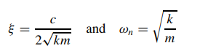

The characteristic polynomial is



from which the eigenvalues are



Consider the following cases

1) 

jw









Over-damped

Figure 5.6

2) 

jw





Critically damped

Figure 5.7

3)

jw









**Figure 5.8 Underdamped system**

4) 







**Figure zero damping**

5) 

So far the location of the poles have been established. Now drawing the root locus of poles for constant  as  varies from zero to grater then 1 . the location of the poles for  have been established as shown below



jw















**Figure 5.10**

If we want to draw a more accurate drawing choose a value for the natural frequency and vary the damping ratio to get more values.

**SUMMARY**

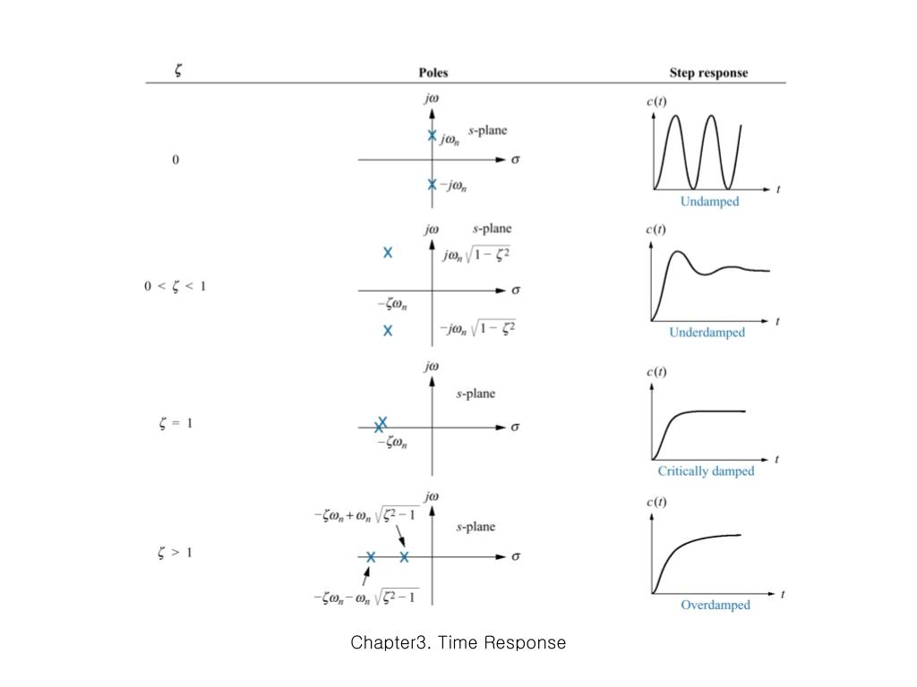

**Figure 5 different damped systems with poles location and corresponding response**

To study the relationship between these eigenvalues and system transient response, we identify five distinct cases in Table 1.0 , determined by the dimensionless damping ratio ξ for a fixed un damped natural frequency ωn.

**Table 1 Damping Ratio versus Step Response Characteristics**

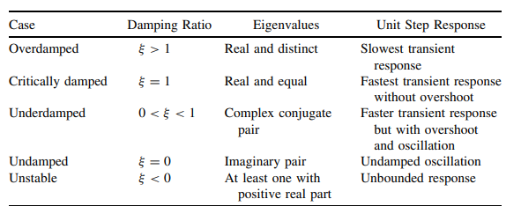

We next relate step response characteristics to the system eigenvalues for the most interesting of these cases: the underdamped case characterized by 0 <ξ< 1. In this case, the complex conjugate eigenvalues are given by



in which is the amped natural frequency in radians per second. The unit step response for a standard second-order system in the underdamped case is

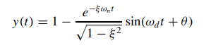

in which the phase angle is given by θ = cos−1(ξ ) and therefore is referred to as the damping angle. This response features a sinusoidal component governed by the damped natural frequency and damping angle that is damped by a decaying exponential envelope related to the negative real part of the eigenvalues. A response of this type is plotted in Figure 5.. For the underdamped case, there are four primary performance characteristics (see Figure 5.0) associated with the unit step response that either directly or approximately can be related to the damping ratio and un damped natural frequency

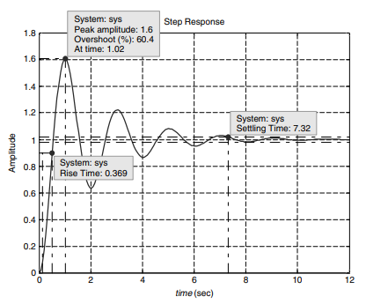

Figure 5 Second order response

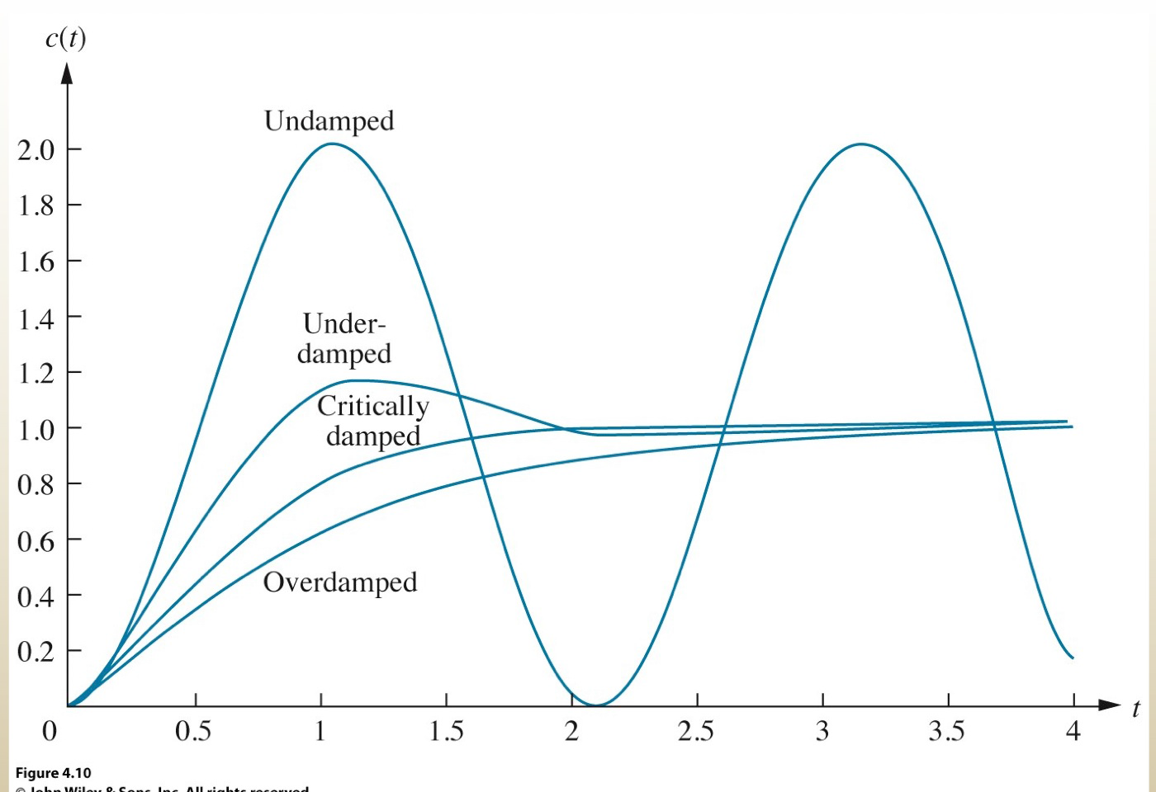

**Figure 6 diffeent responses reflecting the 4 main damping ratios**

The transient response of this second order system for various values of the damping ratio  is shown below.



Figure-----------------

It can be seen that as  decreases the closed loop roots approach the imaginary axis and the response becomes increasingly oscillatory.