Note payable Page 519

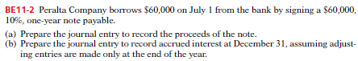

1/7 Cash 60,000

N/P 60,000

31/12

60,000 \* 10% \* 6/12 = 3,000

Interest exp 3000

Interest Payable 3000

Sales Tax Payable: Page 519



Sales 16380 /1.05 = 15600

Sales tax = 16380 – 15600 = 780 Or, 15600 \*5% = 780

Cash 16380

Sales revenue 15600

Sales tax payable 780

Unearned Revenue: Page 519



A- 4000 \* 210 = 840,000

Cash 840,000

Unearned tickets revenue 840,000

B- 840,000 / 12 = 70,000

After first game:

Unearned tickets revenue 70,000

Tickets revenue 70,000

Warranties Payable: Page 519

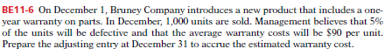

1000 \* 5% \* 90 = 4500

Warranty expenses 4500

Warranty liability 4500

Warranty liability 180

Repair parts 180