Example 1 –

On January 1, 2020, X Co. acquired a patent for $850,000. The legal registration fees amounted to $30,000. The patent has a legal life of 20 years and a useful life of 10 years. Record the acquisition of the patent and the amortization entry on December 31, 2020.

1- Patent cost 850,000 + 30,000 = 880,000

Patent 880,000

Cash 880,000

2- The Patent Amortization:

Annual amortization= 880,000/ 10 = 88,000

Amortization patent exp 88000

Patent 88000

Example 2- Page 479

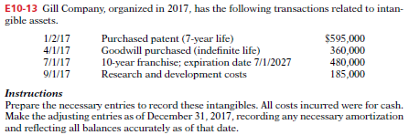

A-

1/2/2017 Patent 595,000

Cash 595,000

4/1/2017 Goodwill 360,000

Cash 360,000

7/1/2017 Franchise 480,000

Cash 480,000

9/1/2017 R&D exp 185,000

Cash 185,000

B- Amortization (Adj. Entries 31/12/2017)

Patent: 595,000 / 7 = 85,000

Goodwill: 360,000 – Indefinite life

Franchise = 480,000 / 10 = 48,000/2 = 24,000

Amortization exp 109,000

Patent 85,000

Franchise 24,000