**State space examples**

***Example 1***

Given the linear single-input, single-output, mass-spring damper translational mechanical system of Figure 1.0. Derive the system model and then convert it to a state-space description. for this system:

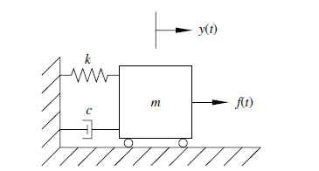

**Figure 1.0 Mass-Friction-Damper System**

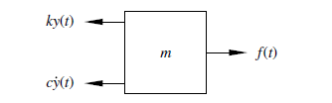

**Figure 2-free body diagram**

The input is force *f (t)* and the output is displacement *y(t)*.Using Newton’s second law, the dynamic force balance for the free body diagram of Figure 2 yields the following second-order ordinary differential equation



We choose to define the state variables as the mass displacement and velocity:

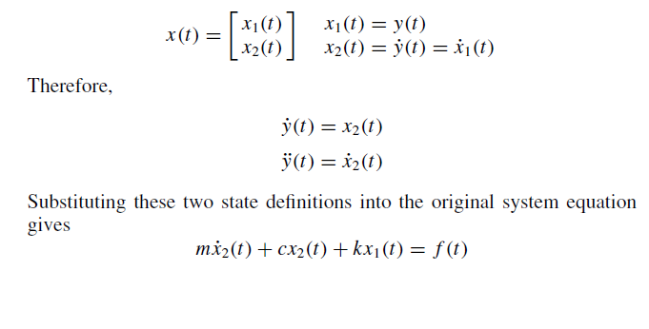

The original single second-order differential equation can be re arranged as a coupled system of two first-order differential equations, that is,

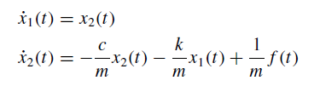

The output is the mass displacement



The generic variable name for input vectors is *u(t)*, so we define:



Writing the preceding equations in matrix-vector form to get a valid state-space description. The general state-space description consists of the state differential equation and the algebraic output equation.

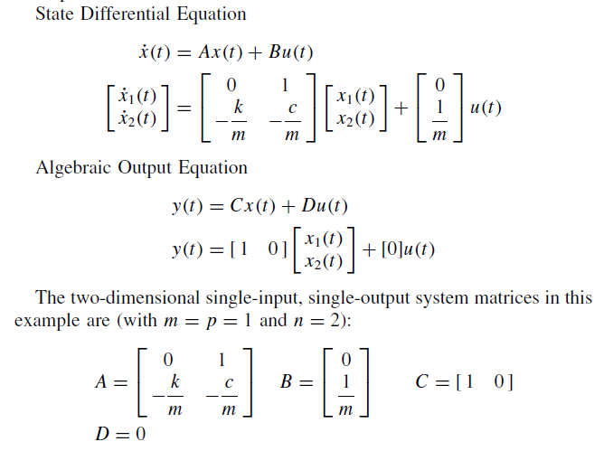

In this example, the state vector is composed of the position and velocity of the mass *m*. Two states are required because we started with one second-order differential equation. Note that *D* = 0 in this example because no part of the input force is directly coupled to the output.

**Example 2**

Consider the parallel electrical circuit shown below

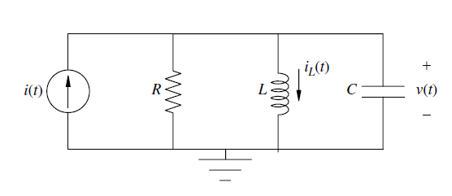

The input is the current produced by the independent current source *u(t)* = *i(t)* and the output is the capacitor voltage *y(t)* = *v(t)*. It is often convenient to associate state variables with the energy storage elements in the network, namely, the capacitors voltage and inductor current. In this example, the capacitor voltage coincides with the voltage across each circuit element as a result of the parallel configuration. This leads to the choice of state variables, that is,

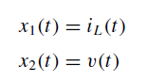

Next, Kirchhoff’s current law applied to the top node produces

Therefore

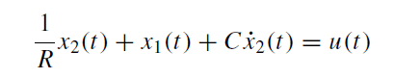

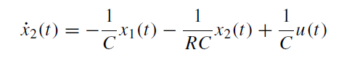

Now we know that the voltage across the inductor is the same as the voltage across the capacitor

Therefore

The output definition *y(t)* =*V*c= *x*2*(t)*,

This pair of coupled first-order differential equations, along with the output definition *y(t)* = *x*2*(t)*, yields the following state-space description for this electrical circuit: State Differential Equation

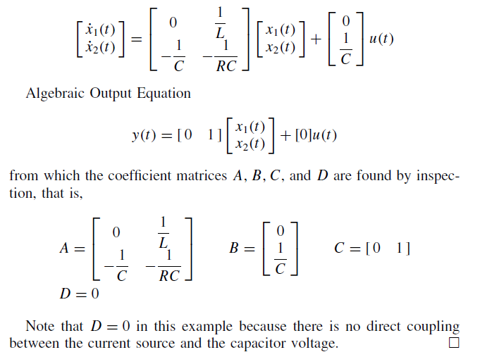

***Example 3***

Consider the translational mechanical system shown in Figure 3, in which *y*1*(t)* and *y*2*(t)* denote the displacement of the associated mass from its static equilibrium position, and *f (t)* represents a force applied to the first mass *m*1.

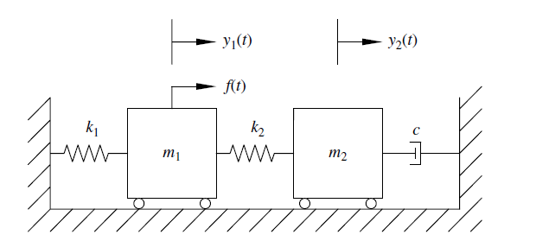

**Figure 3 Translational mechanical system**

The parameters are masses *m*1 and *m*2, viscous damping coefficient *c*, and spring stiffness *k*1 and *k*2. The input is the applied force *u(t)* = *f (t)*, and the outputs are taken as the mass displacements. We now derive a mathematical system model and then determine a valid state-space representation. Newton’s second law applied to each mass yields the coupled second order

differential equations, that is,

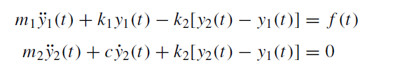

Here, the energy-storage elements are the two springs and the two masses. Defining state variables in terms of mass displacements and velocities yields

Substituting into the equations derived earlier

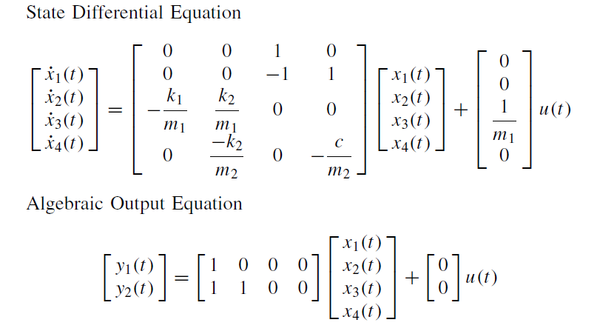

**2nd Method**

from which the coefficient matrices *A,B,C*, and *D* can be identified. Note that *D* = [0 0]T because there is no direct feed through from the input to the output. Now, it was convenient earlier to define the second state variable as the difference in mass displacements, *x*2*(t)* = *y*2*(t)* − *y*1*(t)*, because this relative displacement is the amount the second spring is stretched. Instead we could have defined the second state variable based on the absolute mass displacement, that is *x*2*(t)* = *y*2*(t)*, and derived an equally valid state-space representation. Making this one change in our state variable definitions, that is,

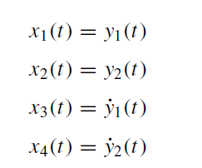

This way we derive

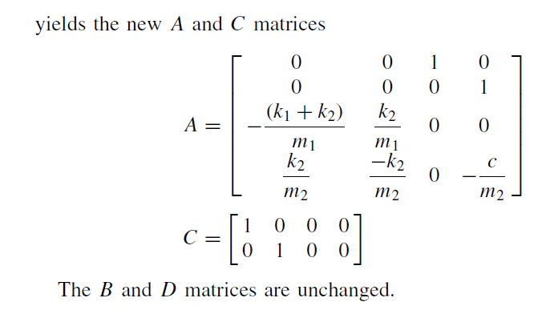

***Example 4*** This example derives a valid state-space description for a general third-order differential equation of the form

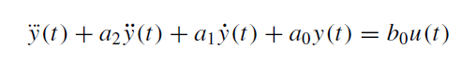

The associated transfer function definition is

Therefore

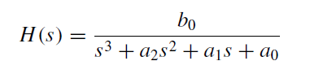

Now to derive the state space equation Define the following state variables:

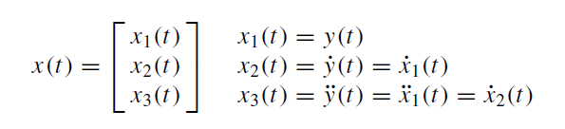

Substituting these state-variable definitions into the original differential equation yields the following:



The state differential and algebraic output equations are then State Differential Equation

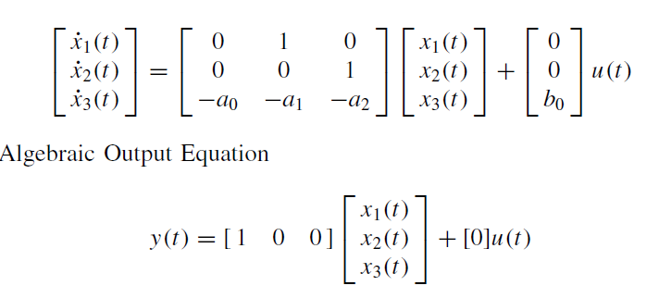

from which the coefficient matrices *A,B,C*, and *D* can be identified. *D* = 0 in this example because there is no direct coupling between the input and output.

***Example 5***

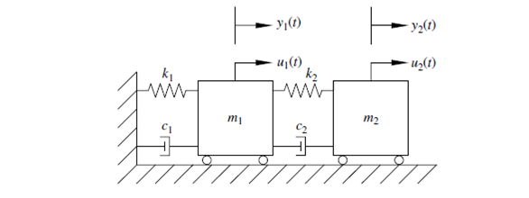

**Now Apply Newton’s second law twice, once for each mass to derive two second order dynamic equation for motion**

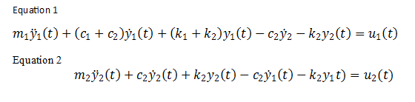

Example 5 is a multiple-input, multiple output system with two inputs *ui (t)* and two outputs *yi (t)*. We can express the two preceding second order differential equations in standard second-order matrix-vector form, *M*¨ *y(t)* + *C* ˙ *y(t)* + *Ky(t)* = *u(t)*, that is,

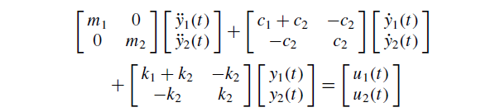

***State-Space Description*** Next, derive a valid state-space description for this system. That is specify the state variables and then derive the coefficient matrices *A,B,C*, and *D*. We present two distinct cases:

a. Multiple-input, multiple-output: Both inputs and both outputs

b. Single-input, single-output: One input *u*2*(t)* and one output *y*1*(t)*

***Case a: Multiple-Input, Multiple-Output*** Since we have two second order differential equations, the state-space dimension is *n* = 4, and thus we need to define four state variables *xi (t ), i* = 1*,* 2*,* 3*,* 4. Again, energy storage elements guide our choice of states:

From these definitions we find

Therefore to find we go back to equation 1 and equation t and reaarenge for the highest derivitives

Substitute into equation 1 and equat ion 2 yields

Similarly from quation 2

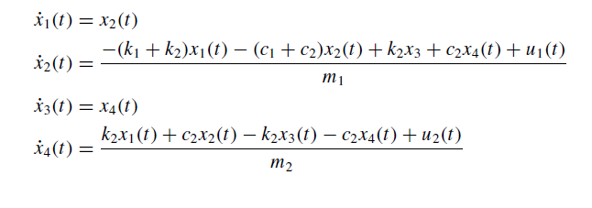

The state differential equation is

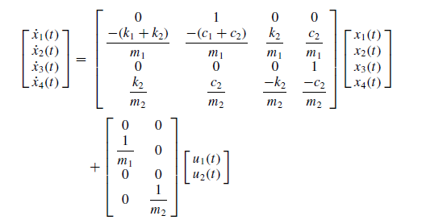

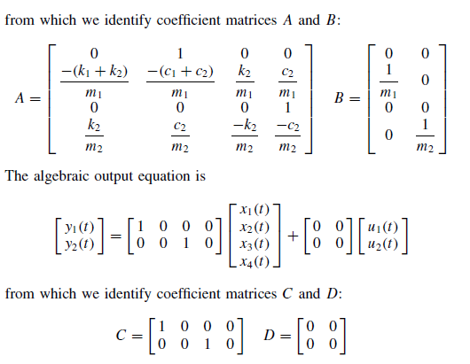

This is a four-dimensional multiple-input, multiple-output system with

*m* = 2 inputs, *p* = 2 outputs, and *n* = 4 states.

***Case b: Single-Input, Single-Output: One Input u*2*, One Output y*1*.***

Remember, system dynamics matrix *A* does not change when considering different system inputs and outputs.

For the single-input, single-output case *b*, only coefficient matrices *B,C*, and *D* change. The state differential equation now is:

