Chapter **27**

Current and Resistance

|  |  |  |  |
| --- | --- | --- | --- |
| **Ch. 27: Current and Resistance**  **WK: 7, 8 [3Lect+1]** | Sp2013 | 1,7,15,25,29,53,73 | 3,8,11,31,49,56 |
| Sp2014 | 2,6,8,14,19,21,29 | 4,10,13,23,28,31 |
| Sp2015 | 3, 13, 15, 21 | 5, 11. 14, 40, 43 |
| **3hr** | Sp2016 | 3, 15, 21 | 5, 11. 14, 40, 43 |
| **Ed. 9** | **Fall 2018** | **3, 14, 17, 19** | **5, 11, 40, 43** |
|  | **Fall 2019** | 1, 13, 15, 21, 31, 39 | 5, 11, 14 , 33,40 |
|  | **Sp2020** | **3, 14, 17, 19** | **5, 11, 40, 43** |
| **Sp2021** | **3, 9, 15, 53** | | |

# 27.1 Electric Current

Consider Fig. 27.1. The positive charges move

perpendicular through the area *A*. ΔQ is the amount of charge that passes through this area in a time interval *Δt* ,

the average current Iav is equal to the charge that passes

through *A* per unit time:

*Iav*

 *Q*

*t*

(27.1)

If the rate at which charge flow varies in time, then the current varies in time;

we define the instantaneous current I as the differential limit of the average current:

*I*  *dQ*

*dt*

The SI unit of current is the ampere (A):

*1 A*  *1 C*

*1 s*

That is, the current 1 A is equivalent to 1 C of charge passing through the surface area in 1 s.

The charges passing through the surface in Figure 27.1 can be positive or negative, or both. It is **conventional to assign to the current the same direction as the flow of positive charge.**

The direction of the current is opposite the direction of flow of electrons.

**The moving charge (positive or negative) are termed as mobile charge carrier.**

**Microscopic Model of Current**

Consider the current in a conductor of cross-sectional area *A* (Fig. 27.2). The volume of a section of the conductor of length *Δx* (the gray region shown in Fig. 27.2) is

*volume = A*  *Δx* .

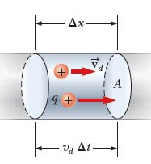If ***n* represents the number of mobile charge carriers per unit volume** (the charge carrier density), the number of carriers in the section is

*nAΔx* .

Therefore, the charge *Q* in this section is

*Q* = number of carriers in the section × the charge of the carrier

*Q=q nA**x*

But

*Δx*  *d* *t*

, where *d*

is the **drift velocity** (average speed of the charge

carriers through the conductor), electrons actually collide with each other and with nuclei and don not move straight, but they have a net average speed in the direction opposite of the applied electric field (due to the applied potential) and proportional to it .

*Q= (n A vd* *t ) q*

The average current in the conductor is

*I*  *Q*  *nqv A*

*avg* *t* *d*

***(Fig. 27.4)***

Rank (ﺻﻨﻒ) the current in these four regions, from lowest to highest.

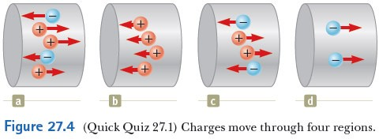

**Answer:** Current (results from motion of positive charges right = motion of negative charges left),

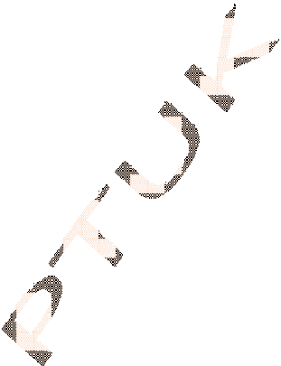

5 mobile

(d) 2 mobile charges (b) 4 mobile charges (c) 4 mobile charges (a) charges.

## Example 27.1 Drift Speed in a Copper Wire

The 12-gauge copper wire in a typical residential building has a cross-sectional area of 3.31×10-6 m2. If it carries a current of 10.0 A, what is the drift speed

of the electrons? Assume that each copper atom contributes one free electron to the current. The density of copper ρ is 8.95 g/cm3. (molar mass of copper Cu = 63.5 g/mole)

### Each atom Cu gives one electron.

***No. of electron per unit volume*** ***n = No × number of moles/cm3.***

### Number of moles/cm3 =

*mass/cm3*  *ρ*  *8.95* 

*0.141 mole/cm3*

*molar mass* *M* *63.5*

### Number of Atoms = no. of electrons = NA  M

*ρ*

***= 6.02 ×1023****×* ***(0.141) = 8.49 ×1022 e/cm3***

### = 8.49×1028 elec. /m3

#### Or one can find the number of moles by

**Volume of one mole =** *molar mass* **=**

*density*

*63.5*  *7.09 cm3*  *7.09*  *10**6 m3*

*8.95*

#### No. of electron /cm3 =

*No(*  *no. of e in 1 mole )* *6.02 ×1023* *28 3*

*n* 

*volume of 1 mole*

 *7.09*  *10**6*

 *8.49*  *10* *electron / m*

*v*  *I*  *10*

 *2.22*  *10**4 m / s*

*d* *nqA* *8.49*  *1028*  *1.6*  *10**19*  *3.31* *10**6*

# 27.2 Resistance

Current flows through the conductor under the action of an electric filed supplied by a battery, charges move inside it, and it is no longer in electrostatic equilibrium, the electric field inside is not zero.

The **current density** J inside the conductor is defined as the current I per unit area.

*J*  *I A*

 *nqvd*

, and has **SI unit of A/m2.**

#### Ohm’s law:

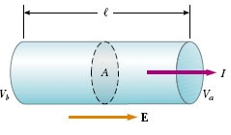

For many material (including conductors) the current density is proportional to the electric field, i.e.

*J*  *σ E*

Where **σ** is called the **electrical conductivity** of the

material and the material is said to be ohmic, nonohmic do not satisfy Ohm’s law.

The electric field is related to the potential difference that produces it across a wire of length l and cross sectional area A by

*Vb*  *Va*  *V*

 *El*

*J*  

*E*   *V*

⇒ *V*

 *J* *l*   *l*  *I*

*l*   

⬧ *A*

 

The quantity

 *l* 

is called the **resistance** of the material

 

⬧ *A*

 

*R*  

  *A* 

 

*l*   *V*

*I*

#### SI unit of R is volt/ampere = ohm

*1*  *V*

*A*

The inverse of the conductivity is **the resistivity ρ**

❒  *1* ; and has units of (Ω.m).

⬧

In terms of ρ, R is given by

*R*   *l*

*A*

Resistances in circuits are called resistors and are of tow types: composite of carbon and wire-wounded resistors (wire coil). There values are given by coded- colour system.

Plot of **V** vs. **I** for a conductor gives **straight line relationship whose slope determines the resistance R**. Every ohmic material has a characteristic resistivity ρ that depends on the properties of the material and on temperature.

Additionally, as you can see from Equation above, the resistance R of a sample depends on geometry (ﺍﻟﻬﻨﺪﺳﻲ ﺍﻟﺸﻜﻞ ) as well as on resistivity. The resistivity (or its inverse the conductivity) is a physical property of the material and depends on the temperature of the sample.

**Example 27.2 The Resistance of Nichrome Wire**

The radius of 22-gauge Nichrome wire is 0.32 mm.

1. Calculate the resistance per unit length of a 22-gauge Nichrome wire, which has a radius of 0.321 mm. (ρ=1.5×10-6 Ω.m)

*A*   *r 2*  *3.14*  *( 0.32*  *10**3 )2*  *3.24*  *10**7 m2*

*R*  

 *1.5*  *10**6*  *.m*

 *4.6* 

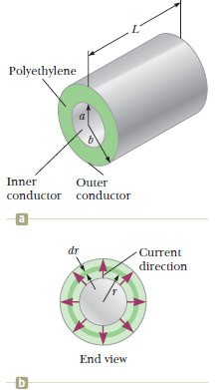*l* *A* *3.24*  *10**7 m2* */ m*

1. If a potential difference of 10 V is maintained across a 1.0-m length of the Nichrome wire, what is the current in the wire?

*I*  *V*  *10*

 *10*

 *2.2 V*

*R* *4.6*  *l* *4.6*  *1*

## Example 27.3 The Radial Resistance of a Coaxial Cable

Coaxial cables are used extensively for cable television and other electronic applications.

A coaxial cable consists of two cylindrical conductors. The gap between the conductors is completely filled with silicon, as shown in Figure

27.8a, and current leakage through the silicon is unwanted. (The cable is designed to conduct current along its length.) The radius of the inner conductor is 0.5cm the radius of the outer one is 1.5cm and the length of the cable is 15.0cm . Calculate the resistance of the silicon between the two conductors.

If current is to flow radialy outwards. For an infinitesimal of length dr for concentric circular element of surface area A, r changes from a to b and

*dr* *dr*

❒ *b dr*

❒  *b* 

*dR*  

*a*

 

 

*A* *2* *rl*

⇒ *R*  *2* *l*  *r*

 *2* *l ln* *a* 

*R*   *ln* *b*   *640* *ln*

 *1.5*   *851* 

*2* *l*

 *a* 

*2*  *0.15*

 *5* 

   