**Name:………………………………. Date:…………………………………….**

**Exp# 5: performance indices of first and second order systems**

**Aims:**

**1… …………………………………………………………**

**2… …………………………………………………………**

**Equipments and tools used:**

1. **………………………………………………………………….**
2. **………………………………………………………………….**

**Plot the executive diagram you have done where transfer function for**

**1st order system is = 1/ (2s+1);**

**and second order systems G(s) = 1/(s^2 + 0.6s+1)**

**with step input = 5**

**Plot system response and dynamic error of the first order system:**

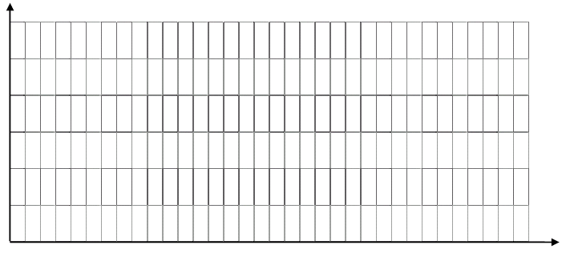

**Plot system response and dynamic error of the second order system:**



**Plot: AE, TAE, SE, TSE for the 1st order system**



**Plot: AE, TAE, SE, TSE for the 2nd order system**



**Assign the performance index for each of the corresponding curves.**

**Which of these indices ignores the effect of initial error?**

**Which gives importance to initial dynamic error?**

**Which performance index do you prefer to use? Why?**