**1) A ball is thrown directly downward from a height of 30.0 m. It takes 2.0 s to reach the ground. Find the magnitude of the initial velocity.**

**A)5 m/s B) 10 m/s C) 0 m/s D)8 m/s E) 7m/s**

**2)The minimum speed of a projectile during the whole flight is 24 m/s. and the initial speed is 30 m/s what is the projection angle (in degrees)?**

**A) 37 B) 53 C) 60 D)30 E) 90**

**3)The polar coordinates of a point are ( 15 m, 240°) What are the Cartesian coordinates of this point?**

**A) (7.5 ,13) B) (-7.5 ,13) C) (7.5 ,-13) D) (-7.5 ,-13) E) (13 ,-7.5)**

**4)Consider the displacement vectors . A= 4i + 5j B = 2i + 2j. The magnitude of 2A-B**

**A) 14 B) 5 C) 10 D)100 E)9.2**

**5) The position of a particle moving along the x axis is given by: x = 6.0 t2 – 1.0 t3,**

**where x is in meters and t is in seconds. What is the speed of the particle at t=2sec**

**A) 16 m/s B) 12 m/s C) 6 m/s D) 24 m/s E) 20 m/s**

**6) A jet plane lands with a speed of 50m/s and decelerates with 5m/s2 as it comes to rest. From the instant it touches the runway; it moves a distance X and stops, as shown in Figure 2. What is the distance X, measured in meters?**

**A) 100 B) 500**

**C) 250 D) 1000**



**(7)- A boy on the edge of a vertical cliff حافة صخرة 45m high throws a stone horizontally outward with a speed of 20 m/s. It strikes the ground at what horizontal distance from the foot of the cliff? Use g = 10m/s2.**

**A) 10m B)40m C) 50m D)60m**

**8) The polar coordinates of a point are ( 15 m, 240°) What are the Cartesian coordinates of this point**

**A) (7.5 ,13) B) (-7.5 ,13) C) (7.5 ,-13) D) (-7.5 ,-13) E) (13 ,-7.5)**

**9) A ball falls freely, starting from rest. In four seconds of time it travels a distance of:**

**A)125 m B) 35 m C) 80 m D) 45m**

** 10) The vector C⃗ in the diagram is equal to:**

1. **𝐴 −𝐵⃗**
2. **𝐴 +𝐵⃗**
3. **𝐵⃗ −𝐴**
4. **𝐴 𝑐𝑜𝑠𝜃**

**11) A stone is projected horizontally from the top of a building and follows the path ABC as shown in the figure. The direction of the acceleration of the stone at the point B is:**

1. **↓**
2. **→**
3. **↘**
4. **↙**

**12) If A= 2i - 3j and B= i - 2j, then A + 2B equal to**

**a) –j b) 4i-7j c) 4 i+ j d) j**

**13) Acceleration is always in the direction of the**

**a) displacement b) initial velocity c) final velocity d) the net force**

**14)The polar coordinates of a point are ( 30 m, 120°) What are the Cartesian coordinates of this point?**

**A) (15 ,26) B) (-15 ,26) C) (26 ,-15) D) (-26 ,15)**

**15) Consider the displacement vectors . A= 8i + 14j B = 3i + 2j. The magnitude of |A-B|**

**A) 17 B) 5 C) 12 D)10**

**16)** **A stone is thrown vertically upward from the ground. After 6 s, the stone strikes the ground. With what speed was the stone thrown?**

**A) 20 B) 25 C) 12 D)30**

**17) 1.513 + 27.3 =**

**A) 29 B)28.8 C) 28.9 D) 28.81**

**18) The position X of a particle moving along the y axis depends on the time t according to the equation X = at − bt2. The dimensions of the quantities a and b are respectively:**

**A) L2/T, L3/T2 B) L/T2, L2/T**

**C) L/T, L/T2 D) L3/T, T2/L**

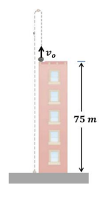**19) A ball is thrown vertically upward from the roof of a building 75 𝑚 high. After 5 𝑠𝑒𝑐𝑜𝑛𝑑𝑠 the ball hits the ground. With what initial velocity was the ball thrown?**

**a)50m/s b)10m/s**

**c)40m/s d)20m/s**

**20) Consider the displacement vectors. A= 4i + 5j B = 2i + 2j. The magnitude of |2A-B|**

**A) 13 B) 5 C) 10 D)14**

**21) A particle moves along the x-axis. Its position as a function of time is given by 𝑥(𝑡) = 4 + 6𝑡 − 𝑡 2 where 𝑥 𝑖𝑠 𝑖𝑛 𝒎 𝑎𝑛𝑑 𝑡 𝑖𝑠 𝑖𝑛 s**

**Find the distance covered by the particle during the first 𝟔 𝒔𝒆𝒄𝒐𝒏𝒅𝒔.**

**A) 18 B) 4 C) 12 D)zero**

**22) If B is added to C=3i+4j , the result is a vector in the positive direction of the y axis, with a magnitude equal to that of C . What is the magnitude of B?**

**A) B) C) 5 D) 9**

**23) A ball is thrown directly upward. Ignore air resistance. The direction of the acceleration of the ball**

**a) is upward while it is travelling up and downward while it is travelling down.**

**b) is downward while it is travelling up and upward while it is travelling down.**

**c) is downward, except at the maximum height when it is zero.**

**d)always downward.**

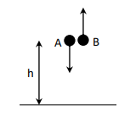**24)Two stones A and B are thrown at the same instant from the top edge of a building of height h with the same speed of 15 m/s. Stone A is thrown straight down and stone B is thrown straight up. The stone A hits the ground below in 4 s. How much time (in s) is needed for the stone B to hit the ground?**

**A) 7s B) 5s C) 6s D) 8s**

**25) The sum of the following measured distances 7.9391 + 6.263 + 11.1 is equal to**

**A)25 B)25.3 C) 25.0 D) 25.31**

**26) 1 mile is equivalent to 1609 m so 55 mile/hour is:**

**A) 15 m/s B) 25 m/s C)30 m/s D)20 m/s**

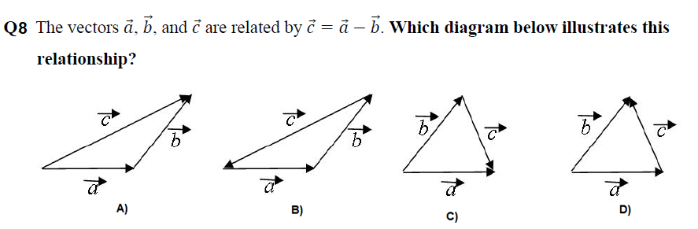

**1-A ball is projected vertically upward with an initial velocity of 10m/s from the edge of a building of height 40 m. The ball reached the ground after**

**A- 1 s B- 2 s C- 3 s D- 4 s**

**2- A particle moves along the x axis. Its position is given by the equation X=2+8t - 2t2**

**with x in meters and t in seconds. The position when the particle stops is:**

**A- zero B- 2 m C- 10 m D- (-10) m**

**3- The Cartesian coordinates of a point is ( (-8 m,-6 m).**

**Then, its polar coordinates are :**

**A- (10 m,217°)**

**B- (5m,-37°)   
C- (10m,37°)**

**D- (10 m,-36°)**

**4- Assume that it takes 7 minutes to fill a 30.0 gal gasoline gas. The rate at which the tank is filled in (m3/s ). [Note that: I gal 231 in3, and 1 in= 0.0254 m)**

**A- rate 2.70 x 102 m3/s**

**B- rate= 2.70x 10--4m3 /s**

**c- rate 2.70 x 104 m3/s**

**D- rate=2.70x 10-2 m3/s**

**5- One of the following equations is dimensionally correct (a acceleration, v velocity, and r is radius)**

**A- a = B- a = C- a = D- a =**

**6- Vectors A and B are given by A=-3i +4j , B=3i -4jThe angle between the vectors is :  
a) Zero**

**b)90**

**c)180**

**d) none of the above**

**7- The vectors A= ai +2j and B=(c-2)i + (a -3)j are equal , where a and c are constants, then (a,c) are  
 a) (3,5)**

**b) (5,7)**

**c) (3,2)**

**d)2,3**

**8- A ball is thrown vertically upward with an initial velocity of 30 m/s after 5 sec it’s velocity is**

**a. 20 m/s**

**b. -20m/s**

**c. 30 m/s**

**d. -30 m/s**

**9- The result of sum (5.0 +1.00 +3.143 + 3) will have...... significant figures.**

**a. one**

**b. two  
c. three**

**d. four**