Final exam solution model

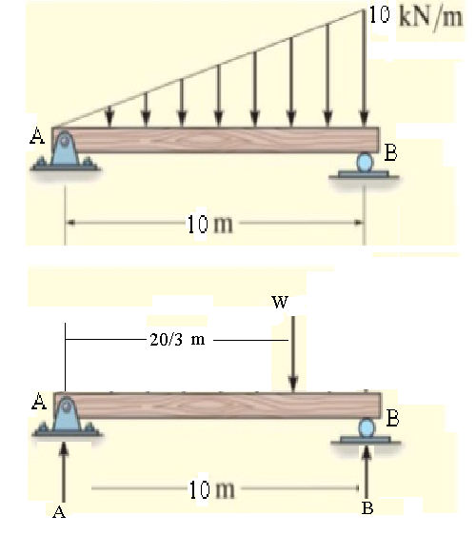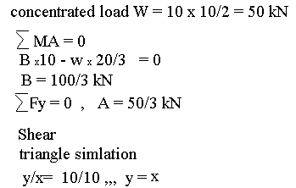

W= 1/2 X2

V+w = A = 50/3 kN

**V = 50/3 – 1/2 X2**  parabolic with negative singn

V = 0 when X = (100/3)1/2 = 5.77 m

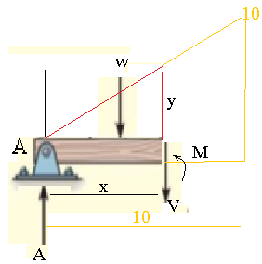V> 0 for X < 5.77

V< 0 for X > 5.77

At X = 10, V= -100/3 (max)

At X= 0, V = 50/3 kN

Moment :

M + w x X/3 – 50/3 x X =0

**M= (50/3) X – (1/6)X3 (cubic equation)**

M = 0 at X = 0 and at X = 10 m

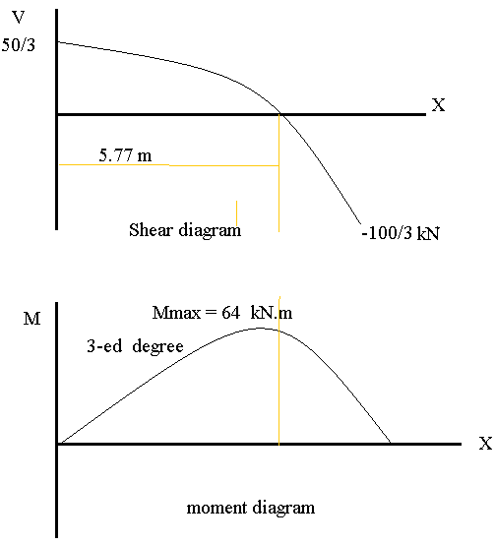To find M max differentiate and equal to

Zero X = 5.77 m

MMax  = 64 kN.m