Exercises

Q1

Write a program that inputs three integers from the keyboard and prints the sum, average, product, smallest and largest of  
these numbers. The screen dialogue should appear as follows:

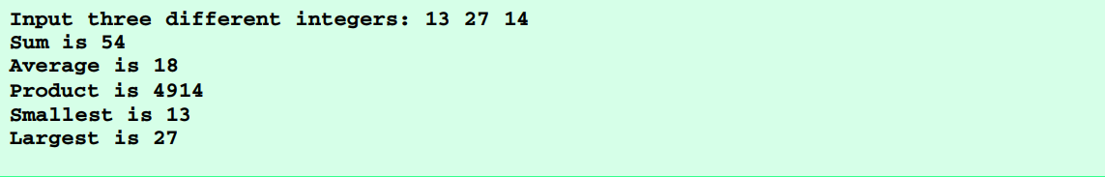

Q2

Write a program that reads an integer and determines and prints whether it is odd or even. (Hint: Use the modulus operator.  
An even number is a multiple of two. Any multiple of two leaves a remainder of zero when divided by 2.)

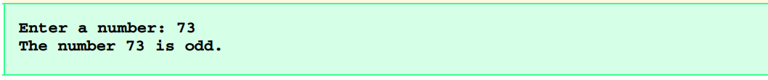

Q3

Write a program that reads in two integers and determines and prints if the first is a multiple of the second. (Hint: Use the  
modulus operator.)

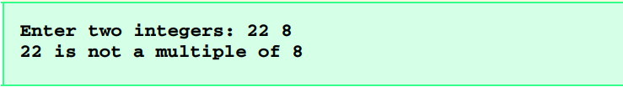

Q4

Write a program that inputs a five-digit number, separates the number into its individual digits and prints the digits separated from one another by three spaces each. (Hint: Use the integer division and modulus operators.) For example, if the user types  
in **42339** the program should print

