Page 434

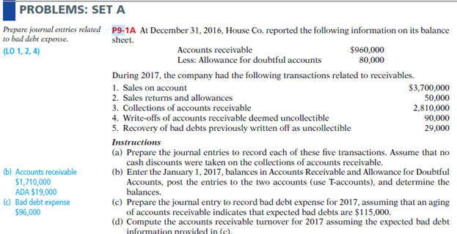

Solution:

A-

1- A/R 3,700,000

Sales revenue 3,700,000

2- Sales return 50,000

A/R 50,000

3- Cash 2,810,000

A/R 2,810,000

4- AFDA 90,000

A/R 90,000

5- A/R 29,000

AFDA 29,000

Cash 29,000

A/R 29,000

B- T- Account

C-

Bad debt exp 96,000

AFDA 96,000

D- 31/12/2017

A/R = 1710000

AFDA = (115,000)

**Turnover (Net realizable value) 1,595,000**