|  |  |
| --- | --- |
| Experiment No : 6 | Key pad |

**Objectives:**

To learn about key pad and how to connect it to PIC 16f877a and do some application

**Keypad :**

A keypad is a set of buttons arranged in a block or "pad" which per digits, symbols or alphabetical letters. Pads mostly containing numbers are called a numeric keypad. Numeric keypads are found on [alphanumeric keyboards](https://en.wikipedia.org/wiki/Alphanumeric_keyboard) and on other devices which require mainly numeric input such as [calculators](https://en.wikipedia.org/wiki/Calculators), [push-button telephones](https://en.wikipedia.org/wiki/Push-button_telephone), [vending machines](https://en.wikipedia.org/wiki/Vending_machine), [ATMs](https://en.wikipedia.org/wiki/Automated_teller_machine), [Point of Sale](https://en.wikipedia.org/wiki/Point_of_Sale) devices, [combination locks](https://en.wikipedia.org/wiki/Combination_locks), and [digital door locks](https://en.wikipedia.org/wiki/Digital_door_lock).

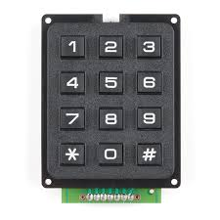 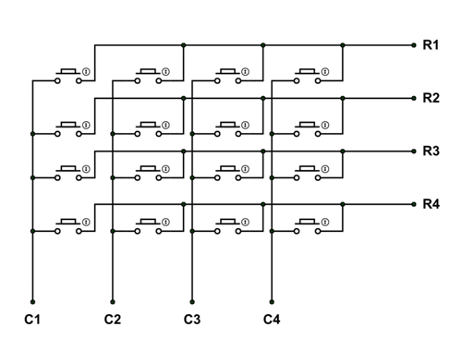

**Example 1:** using keypad to print numbers

The goal from this example to is to use keypad to print numbers

**Components:**

1. PIC16f877a form (Component mode)
2. Lm016L(Component mode)
3. Keypad-phone (Component mode)

**Proteus:**

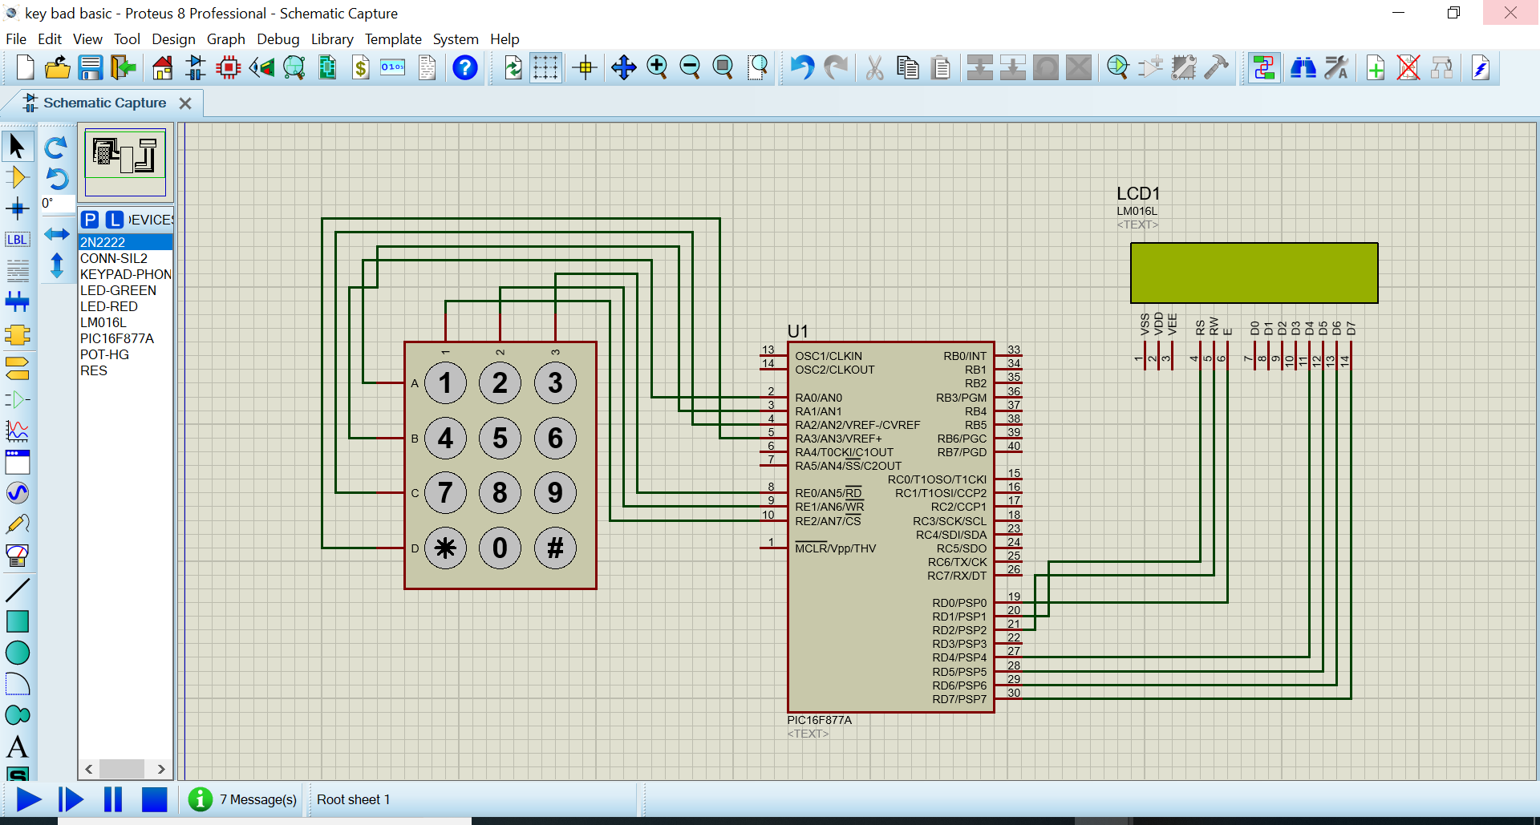

**PIC C:**

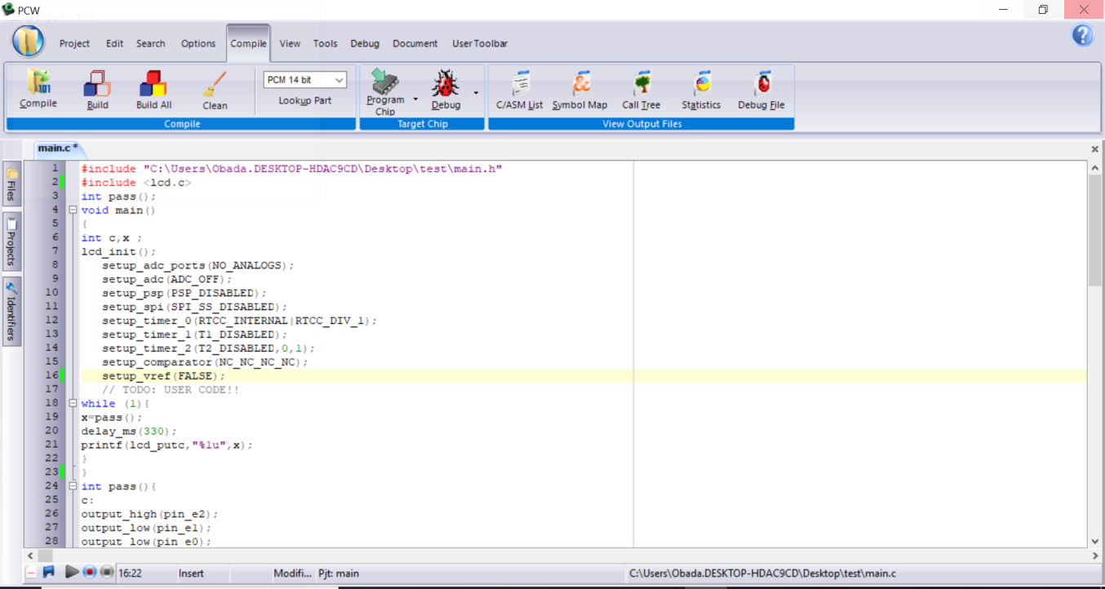

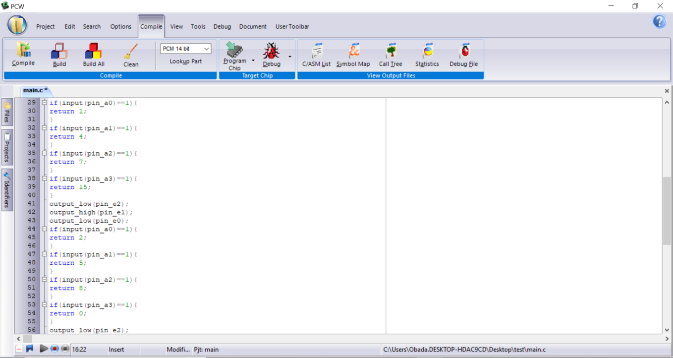

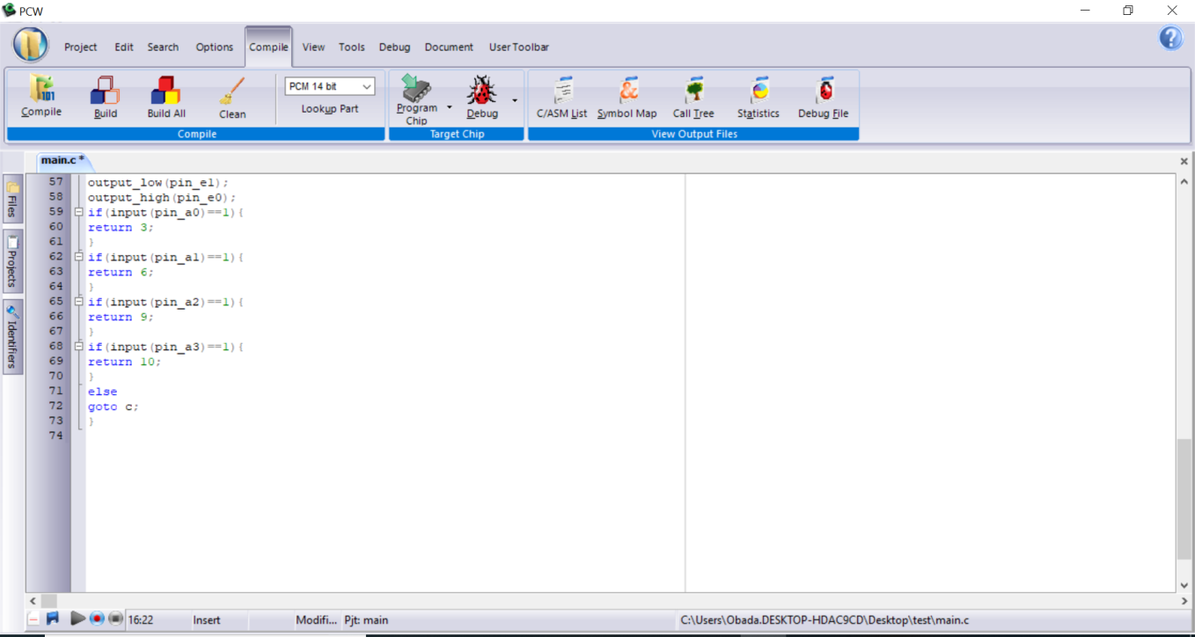

**Example 2:** using keypad to calculate the summation of two numbers

The goal from this example to is to use keypad to calculate the summation of two numbers

**Components:**

1. PIC16f877a form (Component mode)
2. Lm016L(Component mode)
3. Keypad-phone (Component mode)

**Proteus:**

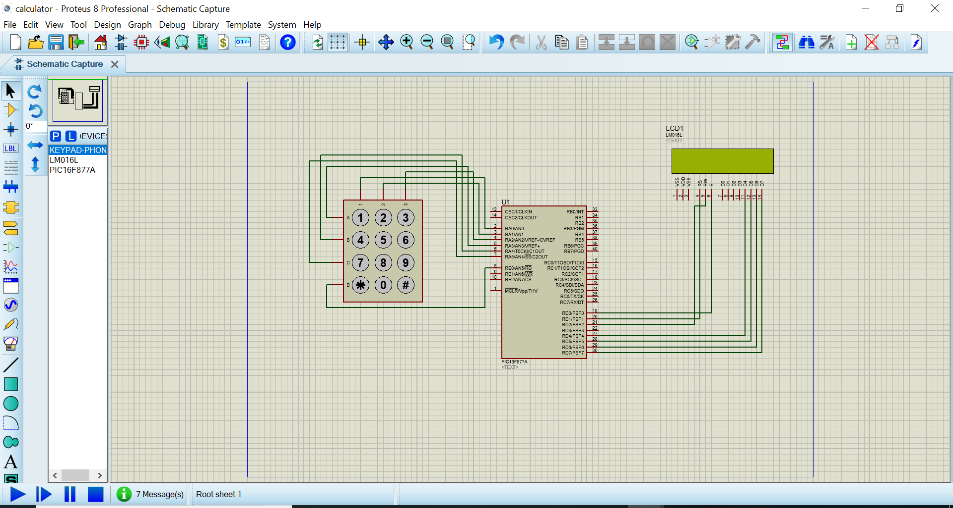

**PIC C:**

