|  |  |
| --- | --- |
| Experiment No: 2 | Title: Digital input/output |

**Objectives:**

To learn about the PIC C compiler program and how to connect it with the proteus program, to learn about digital input/output ports on the pic and make some programs to deal with input/ output ports in the PIC16f877a

**Example 1**: Output on pin

The goal of this example is to make an output with value 1 on pin 0 in port B, which is connected to LED

**Components:**

1. PIC16f877a form (component mode)
2. LED-RED form (component mode)
3. Ground form (Terminal mode)

**Procedure**

1. Draw the Proteus diagram as below:

. 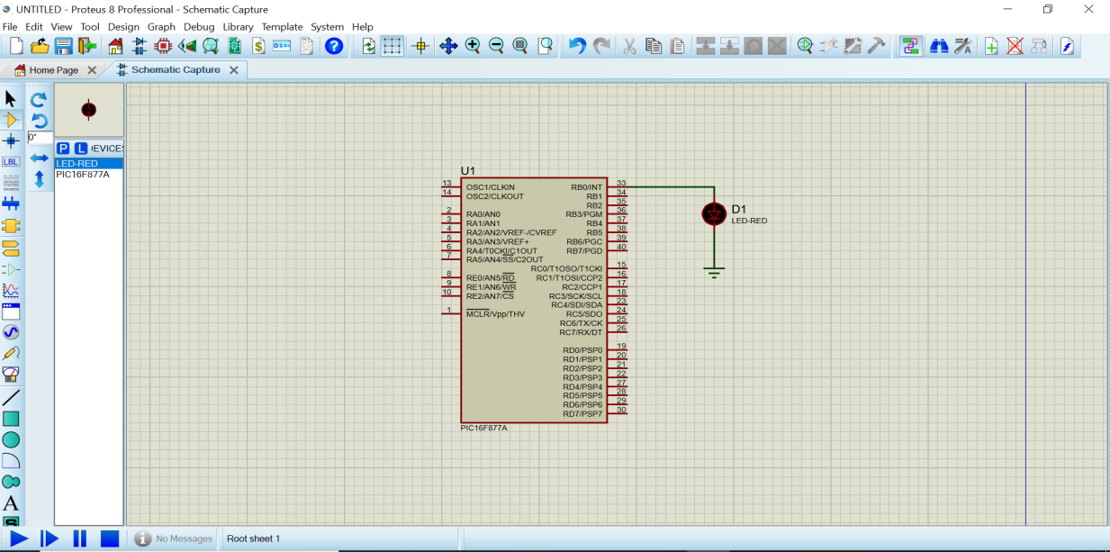

1. Open PIC C compiler program, which has an icon below :



1. Form Project list chose project then PIC Wizard as below :

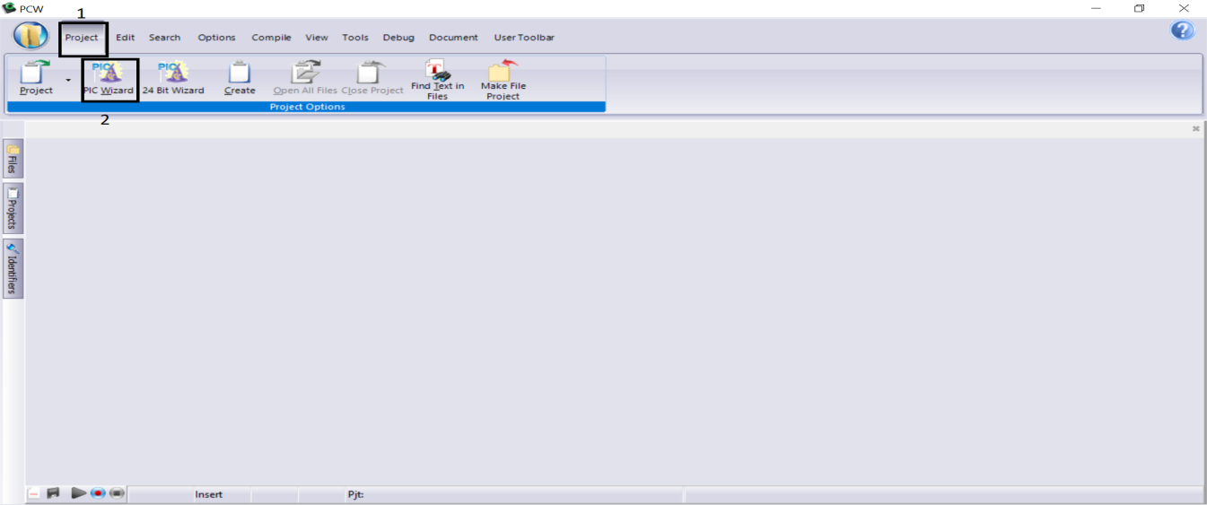

1. Then, after saving the file in the folder with the appropriate name, the figure below is that the Oscillator frequency here is 20000000 with refer to 20 MH, the Oscillator frequency can be changed based on the crystal connected to PIC, then press OK.

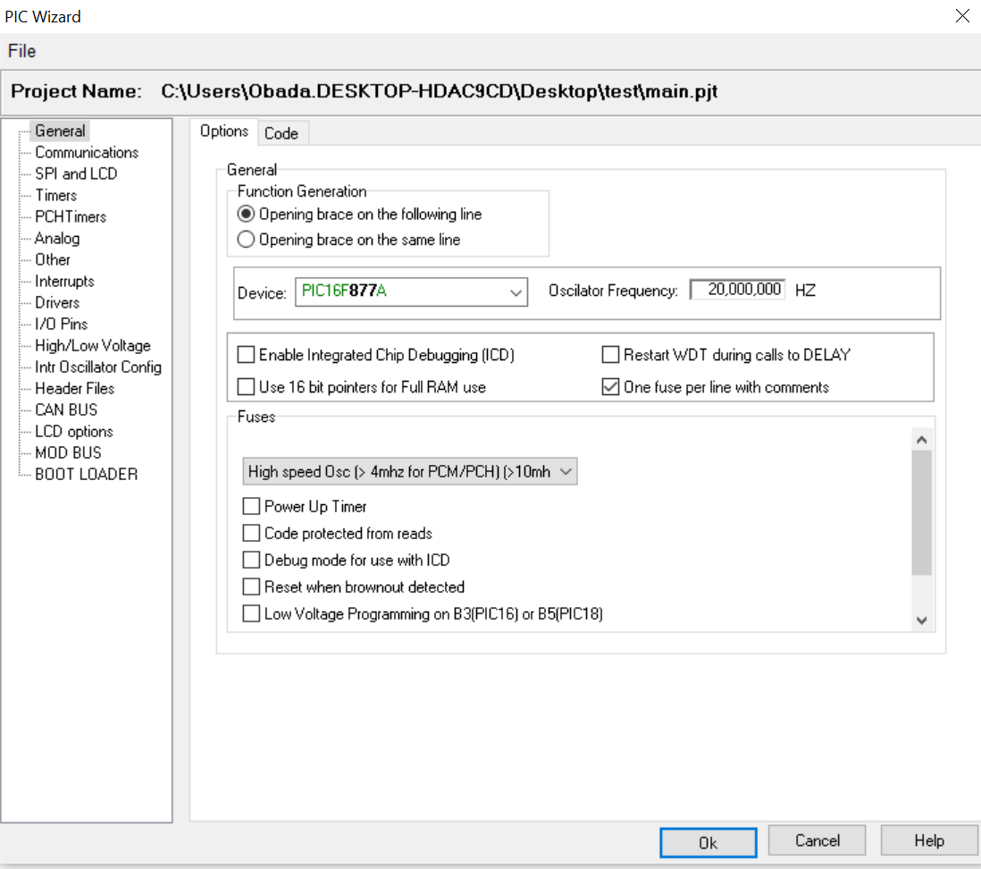

1. Write the program output_high(pin_b0) as in 1 in the picture below, then form the compile list in 2. Press compile as in 3, and the result for compilation appears in 4. The program must have zero error, and don’t worry about warnings; if you have an error, the compiler shows this error in 4 and in which line in order to fix it .

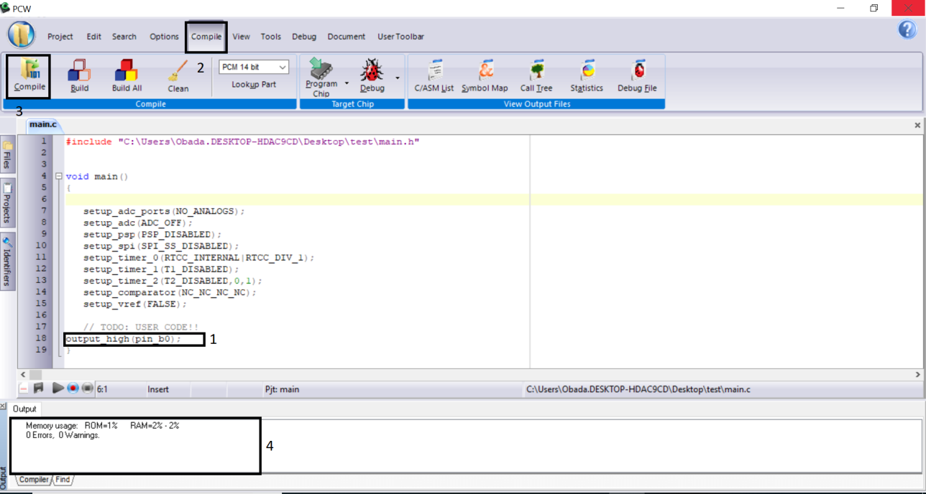

1. Press 1 to bring the file with minimum volume after compilation from the folder that you save in and change the crystal to 20 as in 2, then press OK in 3

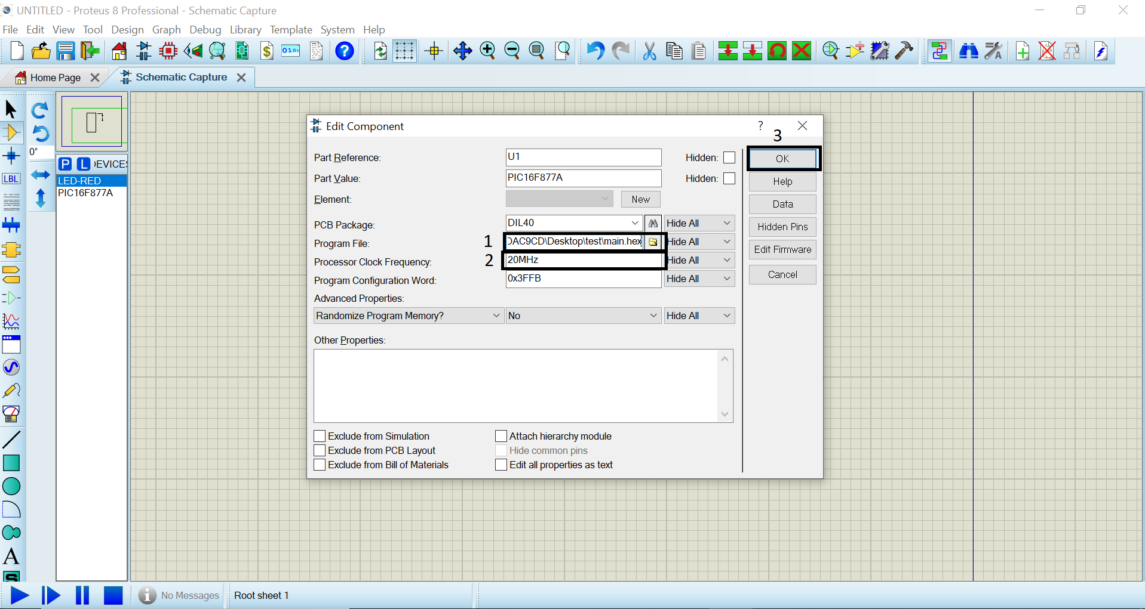

1. Press on the run in 1 as in the figure below; the LED, which is connected to port b pin 0, is turned on:

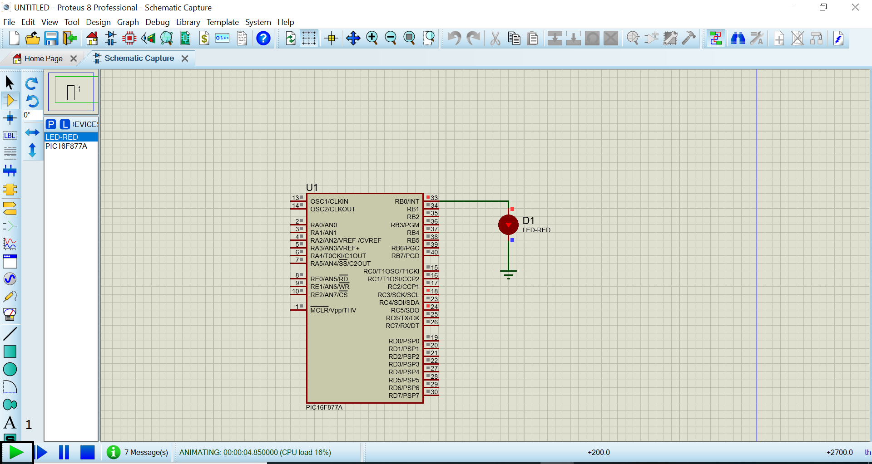

**Example 2:** flasher infinity

The goal of this example is to make an infinity flasher on the pin b0, which is connected to LED

**Components:**

1. PIC16f877a form (component mode)
2. LED-RED form (component mode)
3. Ground form (Terminal mode)

**Proteus:**



**PIC C:** line 1 refer to the infinity loop, line 2 mean to activate the pin b0, which is connected to LED; line 3 is a delay for the activation period since the time for the program is in a micro second; line 4 mean deactivate the pin b0 which connected to LED, line 5 is a delay for deactivation period

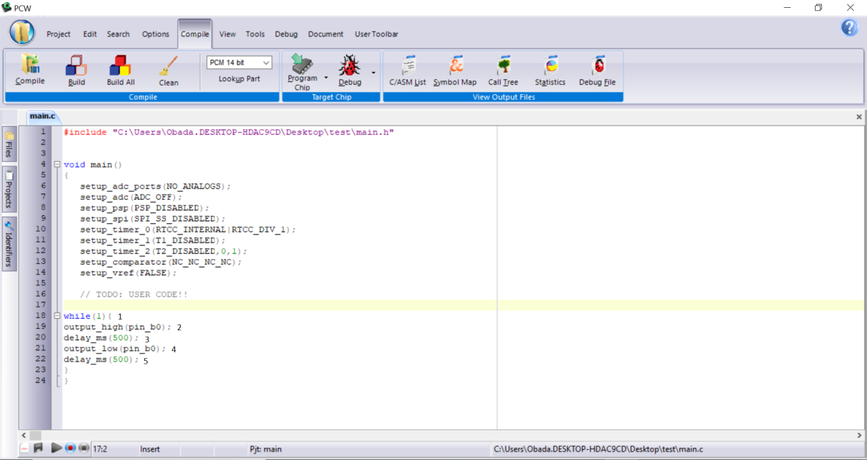

**Example 3:** flasher five times using for loop

The goal from this example is to make a five times flasher on the pin b0, which is connected to LED

**Components:**

1. PIC16f877a form (component mode)
2. LED-RED form (component mode)
3. Ground form (Terminal mode)

**Proteus:**



**PIC C:**

This example is similar to example 2, but instead of using an infinity loop, we use here a times loop for the statement, using the variable i, which is started from zero and finish with value 4 and increment 1 by each cycle when the variable i reach to final value the program is stopped.

Note: Any variable is used in the programming must be defined at the start of the program.

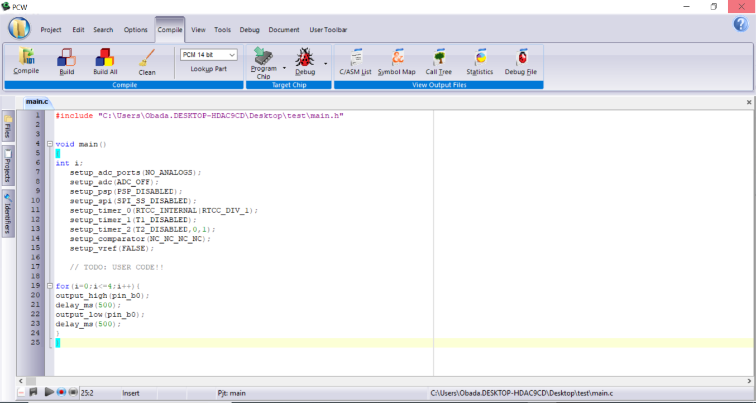

**Example 4:** flasher five times using while loop

The goal from this example is to make a five times flasher on the pin b0 which is connected to LED.

**Components:**

1. PIC16f877a form (component mode)
2. LED-RED form (component mode)
3. Ground form (Terminal mode)

**Proteus:**



**PIC C:**

This example is similar to examples 2 and 3. The program makes a flasher 5 times loop using a while statement; while the variable i is less than 5 the loop is repeated and the variable I increments by 1 until is reaches the value 5; then the condition is false then the loop is finished

Note: Any variable is used in the programming must be defined in the start of the program.

