|  |  |  |
| --- | --- | --- |
| **Word** | **Synonym** | **Antonym** |
| Strict | Firm | Easy-going |
| Punish | Penalize/ give penalty for doing something wrong | Reward |
| Pocket money | A small amount of money given by parents |  |
| Argue | Discuss |  |
| Tell off | Reprimand\ scold |  |
| Ashamed | Embarrassed |  |
| Angry | Furious |  |
| Praise |  | Criticize |
| Encourage | Motivate/ inspire |  |
| Criticize | Say something wrong or bad about someone or something |  |
| Confidence | Trust |  |

**Vocabulary/ Page 20:**

**Vocabulary/ Page 137:**

|  |  |  |
| --- | --- | --- |
| **Word** | **Synonym** | **Antonym** |
| accurate | Precise/ exact/ correct | Inaccurate/ inexact/ wrong |
| tame | Not wild | wild |
| brain | mind |  |
| branch | Section/ division |  |
| challenging | Difficult | easy |
| concentrate | focus |  |
| emotional | Related to people’s feelings |  |
| float |  | sink |
| Get tangled | Get complex/ complicated |  |
| Lack of sleep | A lot of sleep/ plenty of sleep |  |
| rescue | save |  |
| store | Keep/save | lose |

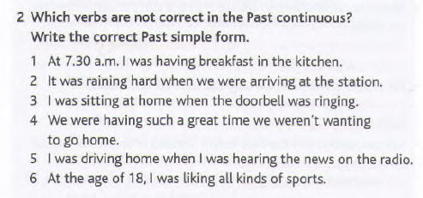

1. Correct
2. It was raining hard when we arrived at the station
3. I was sitting at home when the doorbell rang.
4. We were having such a great time we didn’t want to go home
5. I was driving home I heard the news on the radio.
6. At the age of 18, I liked all kinds of sports.

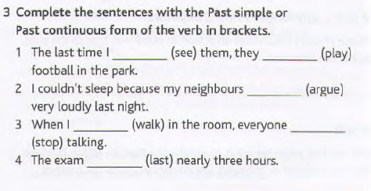

1. The last time I saw them, they were playing football in the park.
2. I couldn’t sleep because my neighbours were arguing very loudly last night.
3. When I walked in the room, everyone stopped talking.
4. The exam lasted nearly three hours.

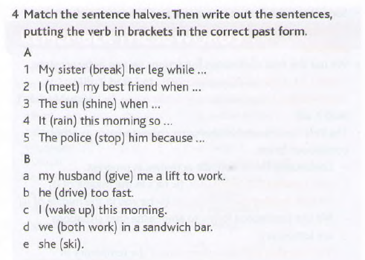

1. My sister broke her leg while she was skiing.
2. I met my best friend when we were both working in a sandwich bar.
3. The sun was shining when I woke up this morning.
4. It was raining this morning so my husband gave me a lift to work.
5. The police stopped him because he was driving too fast.