**Chapter2**

**Modeling of Complex Circuits and Mechanical Systems in the S-domain**

**Electrical Components**

|  |  |  |  |
| --- | --- | --- | --- |
| Components | Time relation | S- relation | Impedance |
|  |  |  |  |
|  |  |  | Ls |
|  | v(t)=R I(t) | v(s)=R I(s) | R |

**Mechanical impedance (Translation)**

|  |  |  |  |
| --- | --- | --- | --- |
| Component | Time relation | S-relation | Impedance |
|  |  |  |  |
|  |  |  | Bs |
|  |  |  | K |

**Mechanical Impedance (Rotational)**

|  |  |  |  |
| --- | --- | --- | --- |
| Component | Time relation | S-relation | Impedance |
|  |  |  |  |
|  |  |  | Bs |
|  |  |  | K |

**Chapter 2**

**Modeling of physical systems**

To understand and control complex systems, one must obtain quantitative **mathematical models** of these systems. It is necessary therefore to analyze the relationships between the system variables and to obtain a mathematical model. Because the systems under consideration are dynamic in nature, the descriptive equations are usually **differential equations.** Furthermore if these equations can be **linearized,** then the **Laplace transform** can be utilized to simplify the method of solution. In practice the complexity of systems lead us to use **assumptions** concerning the system in operation. Then by using the physical laws describing the linear equivalent system, we can obtain a set of linear differential equations. Finally utilizing mathematical tools such as the Laplace transform we obtain a solution describing the operation of the system.

We present a summary of modeling various components which are often used in control systems.

# Electrical components: -

**+ V -**

**+ V -**

**I**

**I**

**R**

**C**

**I**

**L**

**+ V -**

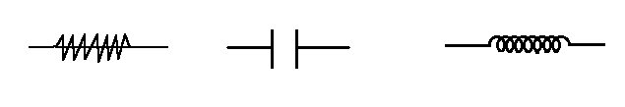

V = I.R I = C V = L

Resistance Capacitance Inductance

**Figure 2.0**

Kirchoff's law: _ Voltage drop around loop = 0.

_ Current at a node = 0.

# Mechanical system elements

Most control systems contain mechanical as well as electrical components, although some systems even have hydraulic and pneumatic elements. From a mathematical view point the descriptions of electrical and mechanical elements are analogous. In fact, we can show that given an electrical device there is usually an analogous mechanical counter part mathematically and vice versa.

The motion of mechanical elements can be described in various dimensions as, translation, rotational or combination. The equations governing the motion of mechanical systems are often formulated directly or indirectly from Newton's law of motion.

**Translational motion**

**The motion of translation is defined as a motion that takes place along a straight line**. The variables that are used to describe translational motion are **acceleration,** **velocity** and **displacement.** Newton's law of motion states that the algebraic sum of forces acting on a rigid body in a given direction is equal to the product of the main of the body and its acceleration in the same direction.

 M: mass, a: acceleration

x

F = m

m

F

**Figure 2.1**

Mass = Kg, acceleration=m/s Force = Newton's (N)

**Mass is considered as a property of an element that stores kinetic energy of translational motion. Mass is analogous to inductance of electrical network.**

**Spring (linear)**

x

x

F = k(x- x) Newton

k = spring constant N/m

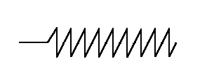

k

F

**Figure 2.2 linear spring**

In practice, a linear spring must be modeled as an actual spring or a compliance of a cable or belt. **In general a spring is considered to be an element that stores potential energy. It is analogous to a capacitor in electric networks.** All springs in real life are nonlinear to some extent. However, if the deformation of the spring is so small its behavior can be approximated by a linear relationship.

**Friction (damper)**

x

x

F = B

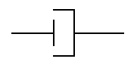

**Figure 2.3 viscous friction**

Whenever there is motion or tendency of motion between two physical elements, frictional forces exist. The frictional forces encountered in physical systems are usually of a nonlinear nature. The characteristics of the frictional forces between two contacting surfaces often depend on such factors as the composition of the surfaces. The pressure between the surfaces, their relative velocity and others so that an exact model description of the friction force is difficult.

**Rotational motion**

**The rotational motion of a body can be defined as a motion about a fixed axis**. The extension of Newton's law of motion for rotational or torque about a fixed axis is equal to the product of the inertia and the angular acceleration about the axis, or



Torques acting on inertia = inertiaangular acceleration

**Inertia**

T(t)

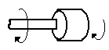

J = angular displacement (Kg.m)

Q(t) = rad

(t)

**Figure 2.4 Inertia**

 N.m

**Inertia J** is considered to be the property of on element that stores the **kinetic energy** of rotational motion. The inertia of a given element depends on the geometric composition about the axis of rotation and its density. For instance, the inertia of a circular disc or shaft about its geometric axis is J = 1/2 M.r Kg.m

# Torsional spring

As with the linear spring for translational motion, a torsional spring constant k, in torque per unit angular displacement, can be devised to represent the compliance of a rod or a shaft when it is subject to an applied torque.

T

T

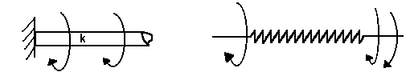

❑

❑

❑

❑

**Figure 2.5 Torsional spring**

T = k(-) where, k = spring constant N.m/rad

# Friction (damper) for rotational motion

T

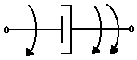

B

❑

❑

**Figure 2.6**

T = B

# Example (2.1): -

Modeling R_L circuit, Vi(t) input, Vo(t) output.

L

+

Vo(t)

-

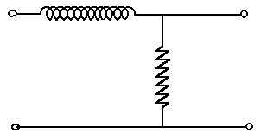

I

Vi(t)

R

**Figure 2.7 LR circuit**

**Time Domain**

Vi(t)= L+Vo(t)

I = 

 Vi(t) =+Vo(t)

# Using Laplace

# Example (2.2): -

Modeling R_C circuit, Vi(t) input, Vo(t) output.

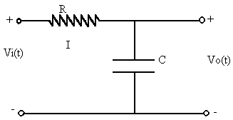

**Figure 2.8 RC circuit**

Time Domain

Laplace Transform

**Example 2.3**

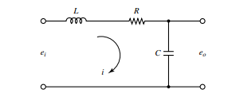

**Figure 2.9 LRC circuit**

**Tme domain equation**

**Laplace transform**

**Example 2.3**

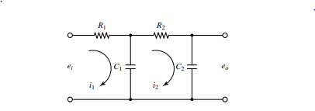

**Figure 2.10 electrical circuit**

**Time Domain**

**Loop 1**

**Loop2**

**Output**

**Laplace domain**

**This yield**

**Example (2.3):**

R

R

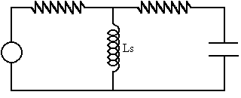

I

I



**Figure 2.11 Electrical circuit**

***Taking loop 1:***

*[sum of all impedances in loop1]* I + [impedances common loop1+loop2]* I= V*

***Taking loop 2:***

*[sum of all impedances on loop2]* I + [impedances common loop1+loop2]* I= 0*

**Applying rule 1:**



**Applying rule 2:**



Manipulating equation 2 by putting whole equation on top of Cs





Multiply both sides by Cs



Therefore the two equations become



Taking inverse Laplace



**Mechanical system**

T 

❑

**Example (2.4):**

❑

B

B



B1

k





J

J

J



**Figure 2.12 Mechanical system**

**Rule**

**[Sum of all impedances acting on J] - [impedances connecting J&J]**

* **[impedances connecting J&J] = T**

equation1

**[Sum of all impedances acting on J] - [impedances connecting J&J]**

2)

* **[impedances connecting J& J] = 0**

equation2

**[Sum of all impedances acting on J ] - [impedances connecting J& J]**

* **[impedances connecting J& J] = 0**

equation3

From equation (3)



Substituting for  in the first equation yields

 equation4

substituting for    in the second equation yields

equation5

Now using the second equation obtain . Then substitute  in the first equation, simplify then workout the transfer function.

From equation (2)



Substituting in the fourth equation



**Now substitute for in above equation and find transfer function**

**Example**

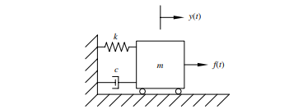

**Figure 2.13 Mechanical system**

**One mass one equation**

**Laplace**

**Example**

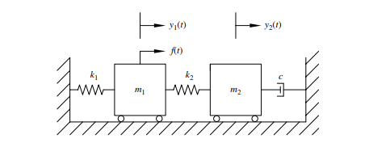

**Figure 2.14 Mechanical Translational System**

**Students are required to finish this question convert to Laplace and derive**

**Example**

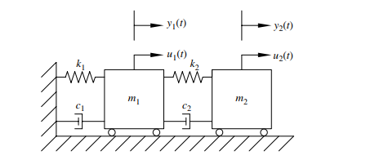

**Figure 2.15 Mechanical System**

**Convert to Laplace**

**Example**

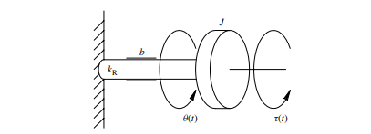

**Figure 2.16 Rotational system**

**Apply Euler’s rotational law (The rotational equivalent of Newton’s second law)**

**This system can be represented by a single second order linear time invariant ordinary differential equation (shown above). This equation is equivalent of a translational mechanical mass-spring-damper system with torque as the input and angular displacement as outut**

**Example**

Consider the system shown in figure 2.17 below obtain the mathematical model by assuming the cart is standing still for t<0 and the spring-mass-dashpot system is also standing till at t<0. In this system u(t) is the displacement of the cart and is the input to the system. The displacement Y(t) is the output (the displacement is relative to the ground). M denotes the mass, b viscous friction and k denotes the spring constant. We assume that the friction force of the dashpot is proportional to and the spring is linear that is the spring force is

### 

**Figure 2.17 Spring mass dashpot system mounted on a cart**

For translational systems Newton’s second law state

Where m=mass a=acceleration

Applying the rule

Impedances acting on mass

Impedances connecting mass on to mass 2 (However there is no mass 2 therefore as there is a second displacement u(t) we assume there is an imaginary mass=0 and write impedances connecting the masses shown red in the equation above)

Taking Laplace transforms assuming zero initial conditions

**Example**

**Obtain the transfer function and for the mechanical system shown in figure 2.18**

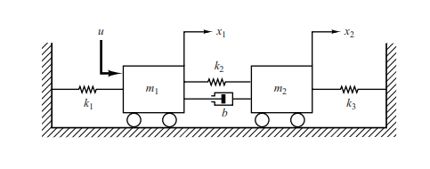

**Figure 2.18 Mechanical System**

The equations of motion for the system are

For mass 1

(black impedances acting on mass 1 and in red impedances common between mass 1 and mass 2)

For mass 2

(black impedances acting on mass 2 and in red impedances common between mass 2 and mass 1)

Simplyfying and taking Laplace transforms yields

From the second equation solve for and substitute in equation 1

From which we obtain

Similarly but now substitute for yields

### Modeling of a DC motor with gears.

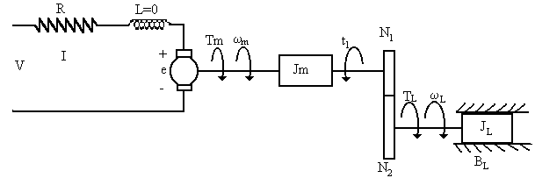

**Figure 2.19 Elctro Mechanical system**

Va = armature voltage (V) Ia = armature current (A)

Ra = armature resistance ( La = armature inductance (H)

Vb = back electromotive force (bemf) potential (V)

Tm = motor torque (N.m) = motor angular velocity (rad/s)

T = load torque on motor shaft (N.m)

T= load driving torque (N.m) load angular speed (rad/s)

Jm = motor inertia (N.m.s/rad) J= load inertia (N.m.s/rad)

B= viscous friction coefficient (N.m.s/rad)

N number of teeth of gear 1.

N = number of teeth of gear 2.

Gear relationship

 (for both acceleration and position).

If N> N speed reduction, torque amplification.

T= 

For ideal gears (without loss)

Input power = output power



# Electrical side

 = R + L+ e = R + e since L=0

e = k = back e.m.f * motor speed

  = R + k



t = k = torque constant*current

# Mechanical equation

t

Tm 



t = Jms + t  t = t - Jm.s (equation 1)

⬥

B

t

T = Js  B 

But T= 

 =  equation2

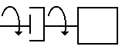

J

Substituting for t in from (equation1) to (equation2): -

 … (equation3)

Equation on the load side substitute  into (equation3)

 

 … (equation4)

However we know that

**



But 



Equation on the motor shaft substituting  in (equation3): -



 





Same as before

 



Both representations are equivalent.

# DC motors in control systems: -

Direct current (dc) motors are one of the most widely used prime movers in industry today. Years ago a majority of the small servomotors used for control purposes were of the ac variety. In reality ac motors are more difficult to control especially for position control and their characteristics are quite nonlinear, which makes the analytical task more difficult. DC motors on the other hand are more expensive

because of the brushes and commutators. Before permanent-magnet technology was fully developed, the torque per unit volume or weight of a dc motor with permanent magnet (PM) field was far desirable. Today with the development of the rare magnet, it is possible to achieve very high torque-volume PM dc motors at reasonable cost.

# Basic operation: -

The dc motor is basically a torque transducer that converts electric energy into mechanical energy. The torque developed on the motor shaft is directly proportional to the fixed flux and armature current. The relationship among the developed torque, flux  and current i is:

T= k.i N.m

k= proportional constant i= armature current = magnetic flux

When the conductor moves in the magnetic field, a voltage is generated across its terminals. This voltage, the back e.m.f which is proportional to the shaft velocity tends to oppose the current flow.

e= k

e= b.e.m.f = shaft velocity (rad/s)

# Basic classifications of PM DC motors: -

In general the magnetic field of a dc motor can be produced by field winding or permanent magnets. Due to the popularity of PM dc motors in control system applications, we concentrate on this type of motor. PM dc motors can be classified according to commutation scheme and armature design conventional dc motors mechanical brushes and commutators. However, in one important class of dc motors the commutation is done electronically. This type of motor is called Brushes dc motors.

# Torque speed curves of a dc motor: -

The torque speed curves of a dc motor describe the static torque producing capability of the motor with respect to the applied voltage and motor speed. With reference to the figure below in the steady state, the effect of the inductance is zero, and the torque equation of the motor is

Tm = kIa =  where Tm, Ia, Ea and  represent the steady state values of the motor torque current applied voltage-speed respectively.

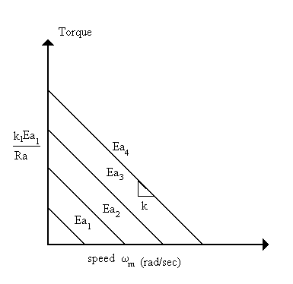

Ea>Ea>Ea>Ea

Maximum Tm



**Figure 2.20**

For a given applied Ea the equation above describes the straight line relation of the torque-speed characteristics of the dc motor. In reality the motor may be subject to two types of saturation or limitations. 1) As Ia increase when La is increased the magnetic circuit will saturate. 2) The second limitations is due to the maximum current that the motor can handle due to the heat dissipation rating of the motor.

In practice, the torque-speed curves of a dc motor can be determined experimentally by a dynamometer.