**Name:………………………………. Date:…………………………………….**

**Exp# 3: properties of PI Controller/ first order system**

**General Block Diagram**

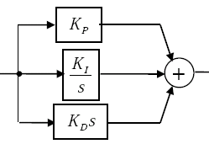

**Aims:**

1. **To minimize the steady state and dynamic error.**
2. **……………………………………………………………**

**Equipments and tools used:**

* 1. **………………………………………………………………….**
  2. **………………………………………………………………….**
  3. **………………………………………………………………….**

**Plot the executive diagram you have done for. G(s)= , Kp max = 6**

**Plot the system response for using only a proportional controller (choose 3 values). What is Kp of the best performance?**

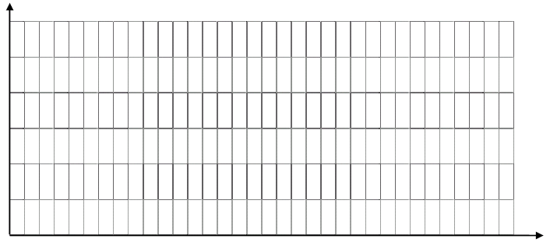

**Adding I controller, plot the system response for increasing the value of Ki. What is the best Ki value?**



**Show the effect of adding PI controller (choose 3 values for KI & KP) what is the best Ki value?**

 What is the effect of P, I, , PI controller on the system?

Give disadvantages of this controller:

Tune the above system