اسم المحاضر : د. اسامة خضر |  | جـامـعــة فلســطيــن التـقــنــيــة –خــضــــوري    الواجب البيتي الاول  للفصل الدراسي الاول 2023 / 2024 | اسم المساق : محاسبة ادارية  رقم المساق :14130224
اسم الطالب :...........................
رقم الطالب :............................
 |  |  | عدد الأسئلة:1
التاريخ: 12/11/2023
النموذج : ( موحد ) |  |  | عدد الصفحات :1
Question 1
Data 1-2-3 is a top-selling electronic spreadsheet product. Data is about to release version 5.0. It divides its customers into two groups: new customers and upgrade customers (those who previously purchased Data 1-2-3, 4.0 or earlier versions. The following information related to the two customers group:
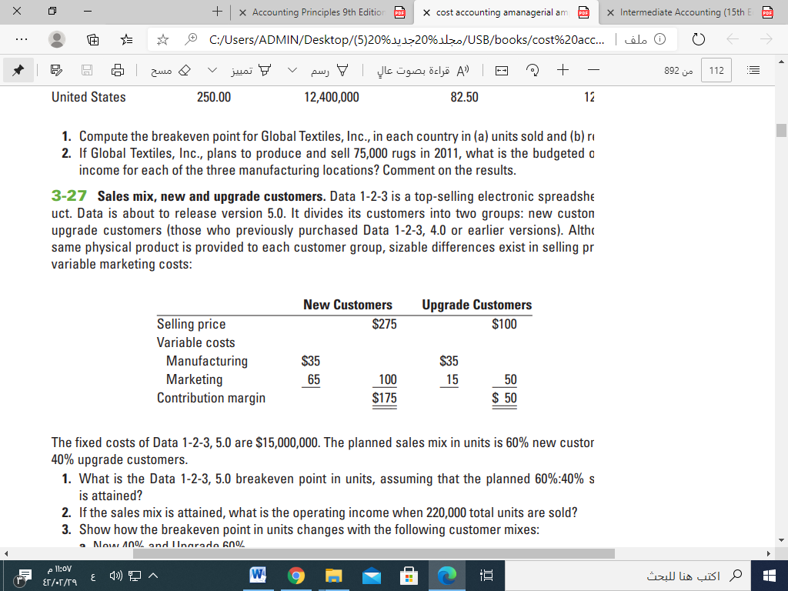
The fixed costs of Data 1-2-3, 5.0 are $20,000,000. The planned sales mix in units is 30% new customers and 70% upgrade customers
Required
Calculate the breakeven point(units and revenues) assuming that the planned 70%:30% sales mix Required is attained

