Understanding the Marketing Mix
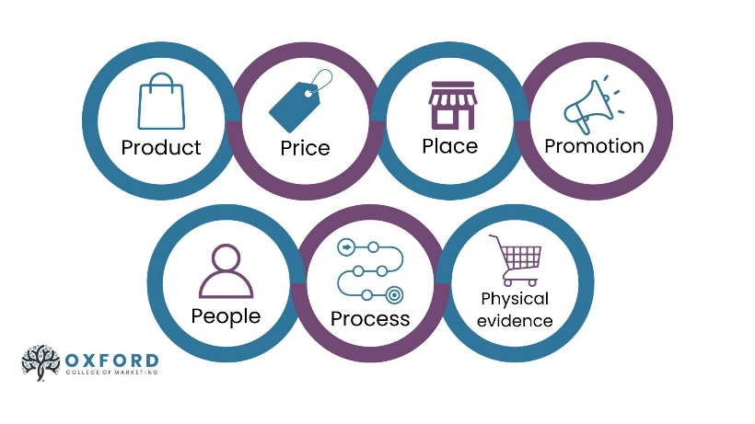
https://blog.oxfordcollegeofmarketing.com/2020/10/08/understanding-the-7ps-of-the-marketing-mix/

What is the marketing mix?
The marketing mix refers to the tactics (or marketing activities) that we have to satisfy customer needs and position our offering clearly in the mind of the customer. It involves the 7Ps; Product, Price, Place and Promotion (McCarthy, 1960) and an additional three elements that help us meet the challenges of marketing services, People, Process and Physical Evidence (Booms & Bitner, 1982).
Know your 7Ps
- Product
This refers to what the company produces (whether it is product or service, or a combination of both) and is developed to meet the core need of the customer – for example, the need for transport is met with a car. The challenge is to create the right ‘bundle of benefits’ that meet this need. So what happens as customer needs change, competitors race ahead or new opportunities arise? We have to add to the ‘bundle of benefits’ to improve the offering, create new versions of existing products, or launch brand new products. When improving the product offering think beyond the actual product itself – value can be added and differentiation achieved with guarantees, warranties, after-sales or online support, a user-friendly app or digital content like a video that helps the user to make the most out of the product.
- Price
This is the only revenue-generating element of the mix – all other marketing activities represent a cost. So it’s important to get the price right to not only cover costs but generate profit! Before setting prices, we need to research information on what customers are willing to pay and gain an understanding of the demand for that product/service in the market. As price is also a strong indication of the positioning in the market against competitors (low prices=value brand), prices need to be set with competitors in mind too.
- Place
This is the ‘place’ where customers make a purchase. This might be in a physical store, through an app or via a website. Some organisations have the physical space, or online presence to take their product/service straight to the customer, whereas others have to work with intermediaries or ‘middlemen’ with the locations, storage and/or sales expertise to help with this distribution. The decisions to be made in this element of the marketing mix concern which intermediaries (if any) will be involved in the distribution chain and also the logistics behind getting the product/service to the end customer, including storage and transportation.
- Promotion
So we have a fantastic product, at an appealing price, available in all the right places, but how do customers know this? Promotion in our marketing mix is about communicating messages to customers, whichever stage they are in the buyer journey, to generate awareness, interest, desire or action.
We have different tools for communication with varying benefits. Advertising is good for raising awareness and reaching new audiences, whereas personal selling using a sales team is great for building relationships with customers and closing a sale. The challenge? To choose the best tool for the job, and select the most effective media to reach our audiences based on what we know about them. If your customer is a regular on Instagram then that’s where you need to be talking to them!
This doesn’t just apply to customers. Communicate to other stakeholders too like shareholders and the wider public to build company reputation. The same principles apply; choose the right tools and media that fit with what you are trying to achieve.
- People
A company’s people are at the forefront when interacting with customers, taking and processing their enquiries, orders and complaints in person, through online chat, on social media, or via the call centre. They interact with customers throughout their journey and become the ‘face’ of the organisation for the customer. Their knowledge of the company’s products and services and how to use them, their ability to access relevant information and their everyday approach and attitude needs to be optimised. People can be inconsistent but with the right training, empowerment and motivation by a company, they can also represent an opportunity to differentiate an offering in a crowded market and to build valuable relationships with customers.
- Process
All companies want to create a smooth, efficient and customer-friendly journey – and this can’t be achieved without the right processes behind the scenes to make that happen. Understanding the steps of the customer journey – from making an enquiry online to requesting information and making a purchase – helps us to consider what processes need to be in place to ensure the customer has a positive experience. When a customer makes an enquiry, how long will they have to wait before receiving a response? How long do they wait between booking a meeting with the sales team to the meeting taking place? What happens once they make an order? How do we make sure reviews are generated after a purchase? How can we use technology to make our processes more efficient? All of these considerations help build a positive customer experience.
- Physical Evidence
Physical evidence provides tangible cues of the quality of experience that a company is offering. It can be particularly useful when a customer has not bought from the organisation before and needs some reassurance, or is expected to pay for a service before it is delivered. For a restaurant, physical evidence could be in the form of the surroundings, staff uniform, menus and online reviews to indicate the experience that could be expected. For an agency, the website itself holds valuable physical evidence – from testimonials to case studies, as well as the contracts that companies are given to represent the services they can expect to be delivere.

