Find the **equivalent capacitance** of given circuit between the point A and B) if the applied voltage across A-B, equal =4 VRMS , 50 Hz.

Note: Take the capacitance of each capacitor as C=10µF) )

**[**886-814-449-655**]**

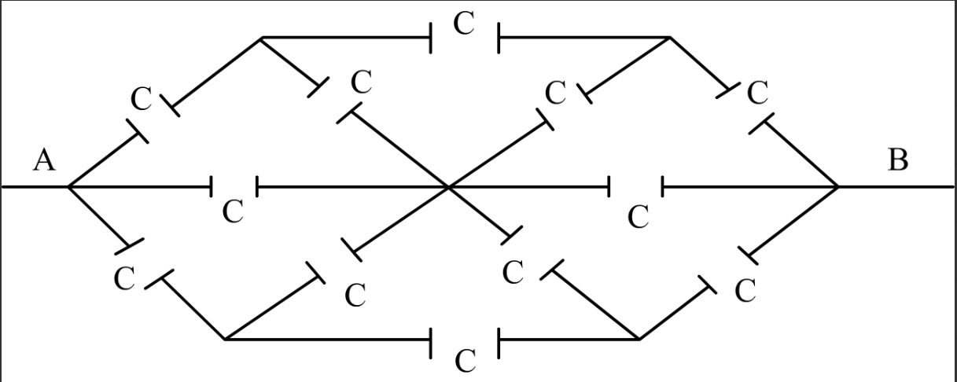

Find the **equivalent capacitance** of given circuit between the point A and B) if the applied voltage across A-B, equal =5 VRMS , 100 Hz.

Note: Take the capacitance of each capacitor as C=20µF) )

**[**828-915-820-466**]**

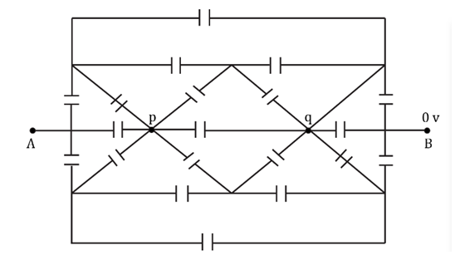

Find the **equivalent capacitance** of given circuit between the point A and B) if the applied voltage across A-B, equal =8 VRMS , 1000 Hz.

Note: Take the capacitance of each capacitor as C=100µF) )

**[**586-617-033-480-475**]**

