1. Using **Kirchhoff theorem** to solve the circuit (B1= 28v,B2=7v)

[045-011-363]

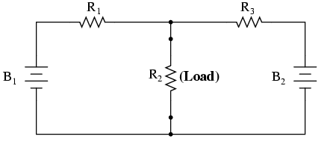

|  |  |  |  |  |  |
| --- | --- | --- | --- | --- | --- |
| **Error %** | **Calculated Current (A)** | **Measured Current (A)** | **Calculated Voltage(V)** | **Measured voltage (V)** | **Resistor (Ω** |
|  |  |  |  |  | **R1=4** |
|  |  |  |  |  | **R2=2** |
|  |  |  |  |  | **R3=1** |

1. Using **SuperPosition theorems** to solve the circuit (B1= 48v,B2=24v)

[624-061]



|  |  |  |  |  |  |
| --- | --- | --- | --- | --- | --- |
| **Error %** | **Calculated Current (A)** | **Measured Current (A)** | **Calculated Voltage(V)** | **Measured voltage (V)** | **Resistor (Ω** |
|  |  |  |  |  | **R1=4** |
|  |  |  |  |  | **R2=2** |
|  |  |  |  |  | **R3=8** |