**Define the fault type/problem** or state if more tests are needed for the following horn circuit. The circuit was tested using a voltmeter when the horn button is activated. The symptom is that the horn sound is not high as it used to be. The test results are listed in the given table. **Which part needs to be replaced**?

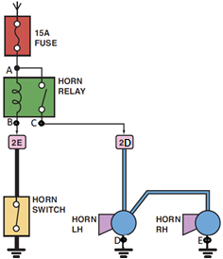

|  |  |  |
| --- | --- | --- |
| Test point | Voltage [ volt] | Fault type/where |
| A | 12 |  |
| B | zero |  |
| C | 8 |  |
| D | zero |  |
| E | 8 |  |

The part needed to be replaced is ………………….

**Calculate the resistance** of one of the horns based on the given fuse rating