**الواجب 1**

**مساق ريادة الأعمال 1 (10 علامات)**

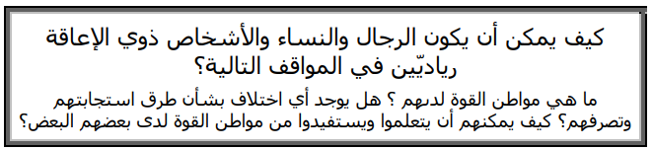



**....................................................................................................................................................................................................................................................................................................................................................................................................................................**



**....................................................................................................................................................................................................................................................................................................................................................................................................................................**



**....................................................................................................................................................................................................................................................................................................................................................................................................................................**

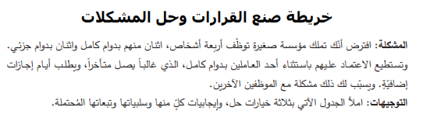

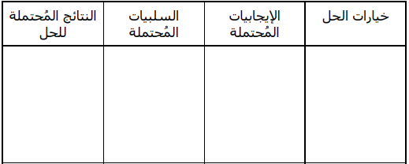

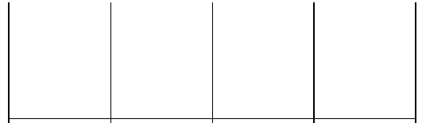

**د. أحمد حمارشة**